Name

Mathematics Extension 1 Year 12
Vector Representation and Operations

Book 1 |  | Version: 260409  Feedback:  https://MrDingMaths.com
Contents
Syllabus Content 2
Introduction to Vectors 4
Geometric Vector Addition and Multiplication 7
Column Vector Notation 16
Parallel and Perpendicular Vectors 21
Unit Vectors and Component Form 27
Calculating Magnitude and Direction 31
Unit Vectors in a Particular Direction 37
Point to Point Notation 40
Position Vectors 48
Solving Geometric Problems with Vectors 55

Syllabus Content
ME1-12-02 operates with 2D and 3D vectors and uses 2D vectors to solve problems involving motion in two dimensions
Vector representation and notation
- Define a vector as a quantity having both magnitude and direction
- Associate vectors with directed line segments and recognise that a vector may have many directed line segments associated with it
- Identify and use notation for vectors in both two dimensions and three dimensions, including $a$, $\underset{∼}{a}$ and $\vec{AB}$, where $\vec{AB}$ is the vector with magnitude and direction those of the directed line segment from $A$ to $B$
- Use notations $\left|a\right|$, $\left|\underset{∼}{a}\right|$ and $\left|\vec{AB}\right|$ to represent the magnitude of a vector
- Describe a position vector as a vector with its tail at the origin
- Represent vectors graphically with and without graphing applications
- Recognise and use the fact that two vectors are equal if they have the same magnitude and direction to solve problems

Introduction to 2D vectors
- Use Cartesian coordinates to represent points in 2-dimensional (2D) and 3-dimensional (3D) space with and without graphing applications
- Use the midpoint and distance formulas in two dimensions and three dimensions
- Identify that, in three dimensions, all points on the $xy$-plane have a $z$-coordinate of 0, and deduce similar properties for points on the $xz$ and $yz$-planes and thus the equations of the three coordinate planes
- Define the zero vector $0$, written as $\underset{∼}{0}$, as the vector with zero magnitude and no direction
- Define unit vectors as vectors of magnitude 1
- Recognise and use $\hat{a}$ and $\hat{\underset{∼}{a}}$ as the notation for the unit vector in the direction of $a$
- Define the standard perpendicular unit vectors $i$ and $j$ in two dimensions and $i$, $j$ and $k$ in three dimensions
- Express 2D vectors in component form, $xi+yj$; as an ordered pair, $\left(x,y\right)$; and in column vector notation $\left(\begin{matrix}x \\ y\end{matrix}\right)$
- Recognise $\vec{AB}=\left(\begin{matrix}u-x \\ v-y\end{matrix}\right)$ as the vector associated with the directed line segment from the point $A\left(x,y\right)$ to $B\left(u,v\right)$ in two dimensions
- Express 3D vectors in component form, $xi+yj+zk$; as an ordered triple, $\left(x,y,z\right)$; and in column vector notation $\left(\begin{matrix}x \\ y \\ z\end{matrix}\right)$
- Recognise $\vec{AB}=\left(\begin{matrix}u-x \\ v-y \\ w-z\end{matrix}\right)$ as the vector associated with the directed line segment from $A\left(x,y,z\right)$ to $B\left(u,v,w\right)$ in three dimensions

Operating with vectors
- Define a scalar as a real number that is used to multiply a vector
- Represent geometrically a scalar multiple of a vector in two dimensions and three dimensions with and without graphing applications
- Perform multiplication of a vector by a scalar algebraically in component form
- Establish and identify $a=kb$, for a non-zero scalar $k$, as a condition for two non-zero vectors $a$ and $b$ to be parallel to each other and determine with justification if two vectors are parallel to one another
- Identify $\left(\begin{matrix}b \\ -a\end{matrix}\right)$ and $\left(\begin{matrix}-b \\ a\end{matrix}\right)$ as vectors perpendicular to $\left(\begin{matrix}a \\ b\end{matrix}\right)$ and with equal magnitude
- Perform addition and subtraction of vectors algebraically in component form, and verify, with and without graphing applications, that geometrically these are obtained using the triangle law or the parallelogram law
- Establish and calculate the magnitude of a vector using $\left|xi+yj\right|=\sqrt{x^{2}+y^{2}}$ for 2D vectors and $\left|xi+yj+zk\right|=\sqrt{x^{2}+y^{2}+z^{2}}$ for 3D vectors
- Use the magnitude of a vector to find the unit vector $\hat{a}=\frac{1}{\left|a\right|}a$ in two dimensions and three dimensions

Introduction to Vectors

- Vectors
A scalar quantity has only size, or magnitude.
E.g. Distance of school from home is 3 km.
Speed of a plane is 800 km/h.
Temperature, length, area, …
A vector quantity has magnitude and direction.
E.g. Displacement of school from home is 3 km at a bearing of 120°.
Velocity of a plane is 800 km/h at a bearing of 225°.
Acceleration, force, weight, …
A vector quantity is often used to represent movement or change.

- Geometric Representation of Vectors
We represent vector quantities using a straight arrow pointing in one direction.

- Identify Vectors
✖ | ✔ |  | ✔ |  | ✖ |  | ✖
Identify which of the following represent vectors.
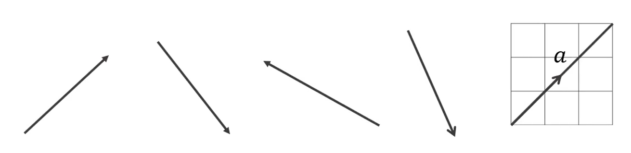 |  |  |  | 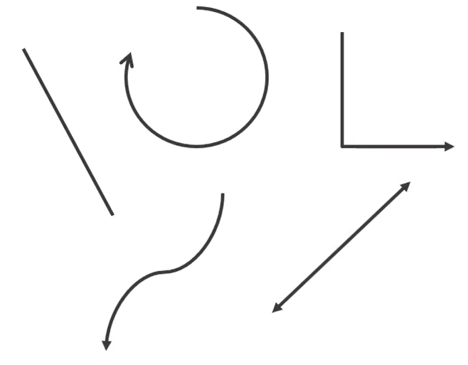

- Geometric Representation of Vectors
The length of the line represents the magnitude of a quantity.
The arrowhead represents the direction of a quantity.
E.g.

3 m North 6 m North-East

Two vectors are equal if they have the same magnitude and direction.

- Interpret geometric representation of vectors.
Identify which of the following vectors represents the largest magnitude.
Identify which of the following vectors represent the same magnitude.
Identify which of the following vector pairs represent the same quantity.
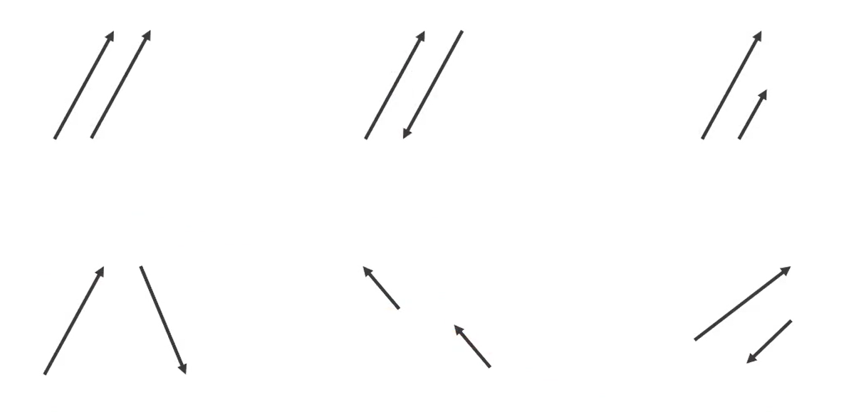

- Vector Variable Notation
Instead of an arrow, we can use algebraic notation to represent both magnitude and direction.
We can communicate the following vector quantity in these ways:
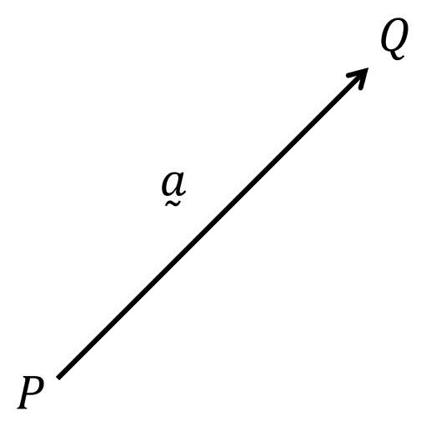
Magnitude & direction: 3 cm northeast OR
3 cm at $45°$ to horizontal
Variable notation: $\overset{̰}{a}$, $a$, or $\vec{a}$

- This booklet will consistently use $\overset{̰}{a}$.
- It is not possible to add nor subtract scalars with vectors.
It is possible to multiply scalars and vectors.

- Interpret vector notation
Which of the following represent vectors?
$$5a+b$$ | $$5\overset{̰}{a}+\overset{̰}{b}$$ | $$-\overset{̰}{c}$$ | $$3(d+2e)$$
$$\overset{̰}{f}+1$$ | $$\frac{\vec{a}}{5}$$ | $$\frac{2}{3}a$$ | $$7-j$$

Geometric Vector Addition and Multiplication

- Investigation Vector addition
- Sarah walks 4 km North, then 3 km North.  Draw a vector for her final displacement. |  |  |  |  |  |  |  |  |  |  |  | - Sarah walks 4 km North, then 3 km South.  Draw a vector for her final displacement. |  |  |  |  |  |  |  |  |  |  |  | - Sarah walks 5 km North, then 12 km East.  Draw a vector for her final displacement.

- Tip and Tail
A vector starts at the tail and ends at the tip.
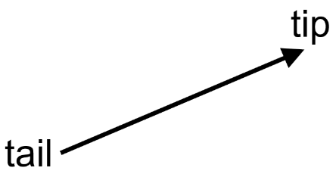

- Identify tip and tail of a vector.
Two vectors are connected tip to tail when you draw the second vector starting from where the first vector ends.
Which of the following shows vectors connected tip to tail?
- Vector Addition (Same Vector)
To add vectors, connect them tip to tail.
Wherever you stop drawing one vector, you start drawing the next.
The resultant vector connects the tail of the first vector to the tip of the final vector.
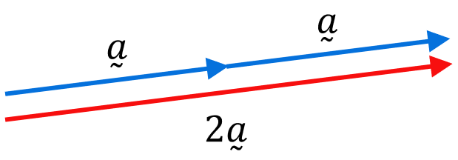

- Interpret vector addition (same vector)
For the vectors given below, sketch the resultant vector on the grid:
- $\overset{̰}{p}+\overset{̰}{p}+\overset{̰}{p}$ |  |  |  |  |  |  |  |  |  |  |  | - $2\overset{̰}{q}$ |  |  |  |  |  |  |  |  |  |  |  | - $\overset{̰}{r}+\overset{̰}{r}+\overset{̰}{r}+\overset{̰}{r}$
$$\overset{̰}{p}$$ |  |  |  |  |  |  |  |  |  |  |  | $$\overset{̰}{q}$$
 |  |  |  |  |  |  |  |  |  |  |  |  |  |  |  |  |  |  |  |  |  |  |  |  |  | $$\overset{̰}{r}$$
- $2\overset{̰}{a}+2\overset{̰}{a}+2\overset{̰}{a}$ |  |  |  |  |  |  |  |  |  |  |  | - $12\overset{̰}{b}$
 |  | $$2\overset{̰}{a}$$
 |  |  |  |  |  |  |  |  |  |  |  |  |  |  | $$3\overset{̰}{b}$$

- Negative Vectors
To make a vector negative, reverse the direction of the arrow.
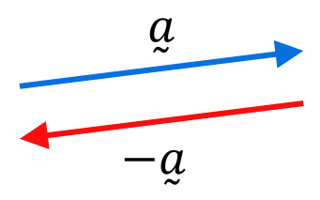

- Interpret negative vectors
For the vectors given below, sketch on the grid:
- $-\overset{̰}{p}$ |  |  |  |  |  |  |  |  |  |  |  | - $-\overset{̰}{q}+\left(-\overset{̰}{q}\right)$ |  |  |  |  |  |  |  |  |  |  |  | - $-3\overset{̰}{r}$
$$\overset{̰}{p}$$ |  |  |  |  |  |  |  |  |  |  |  | $$\overset{̰}{q}$$
 |  |  |  |  |  |  |  |  |  |  |  |  |  |  |  |  |  |  |  |  |  |  |  |  |  | $$\overset{̰}{r}$$
- $2\overset{̰}{a}+(-3\overset{̰}{a})$ |  |  |  |  |  |  |  |  |  |  |  | - $5\overset{̰}{b}-3\overset{̰}{b}$
 |  | $$\overset{̰}{a}$$
 |  |  |  |  |  |  |  |  |  |  |  |  |  |  | $$\overset{̰}{b}$$

- Scalar Multiplication
Scalar multiplication multiplies a vector by a constant factor $λ ∈ R$ (called a scalar).
Scalar multiplication changes the magnitude (length) of the vector.
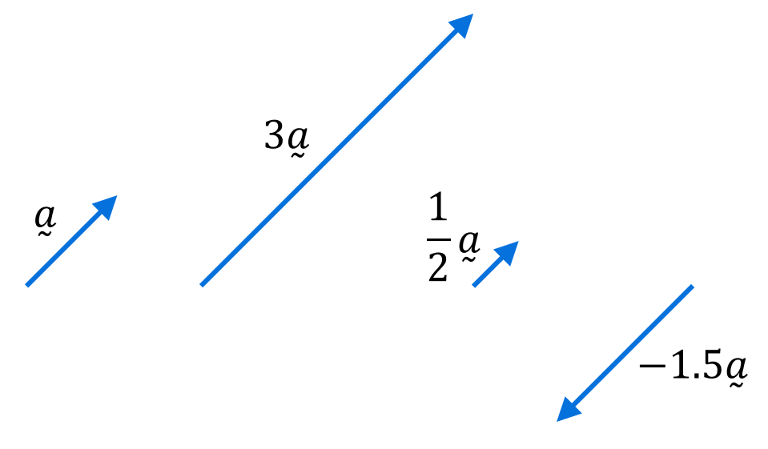

- Interpret scalar multiplication of a vector
For the vectors given below, sketch on the grid:
- $2\overset{̰}{p}$ |  |  |  |  |  |  |  |  |  |  |  | - $2.5\overset{̰}{q}$ |  |  |  |  |  |  |  |  |  |  |  | - $\frac{3}{2}\overset{̰}{r}$
$$\overset{̰}{p}$$ |  |  |  |  |  |  |  |  |  |  |  | $$\overset{̰}{q}$$
 |  |  |  |  |  |  |  |  |  |  |  |  |  |  |  |  |  |  |  |  |  |  |  |  |  | $$\overset{̰}{r}$$
- $-\frac{7}{2}\overset{̰}{a}$ |  |  |  |  |  |  |  |  |  |  |  | - $-4\overset{̰}{b}$
 |  | $$\overset{̰}{a}$$
 |  |  |  |  |  |  |  |  |  |  |  |  |  |  | $$\overset{̰}{b}$$
- Vector Addition
To add vectors, connect them tip to tail.
The resultant vector connects the tail of the first vector to the tip of the final vector.
For vector subtraction, add the negative.
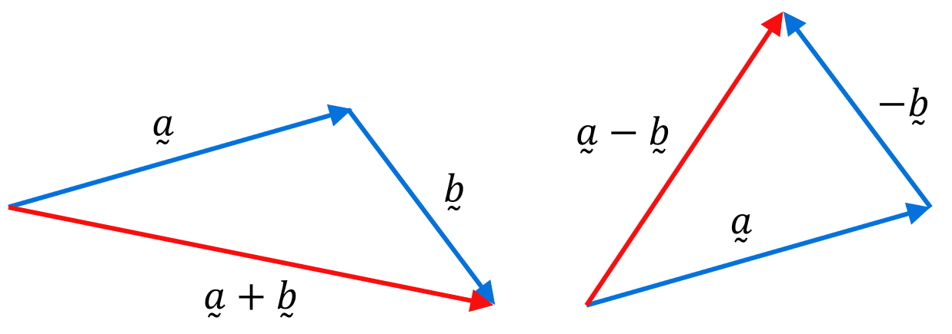
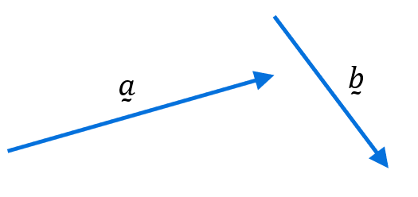

- Vector addition is commutative. You can add in any order: $\overset{̰}{a}+\overset{̰}{b}=\overset{̰}{b}+\overset{̰}{a}$

- Interpret vector addition
For the vectors given below, sketch on the grid:
- $\overset{̰}{p}+\overset{̰}{q}$ |  |  |  |  |  |  |  |  | - $\overset{̰}{q}+\overset{̰}{p}$ |  |  |  |  |  |  |  |  | - $2\overset{̰}{p}+\overset{̰}{q}$ |  |  |  |  |  |  |  |  | - $\overset{̰}{a}+\overset{̰}{b}+\overset{̰}{c}$
 |  |  |  |  |  |  |  |  | $$\overset{̰}{a}$$ |  |  |  |  | $$\overset{̰}{b}$$ |  |  | $$\overset{̰}{c}$$
$$\overset{̰}{p}$$ |  |  |  |  |  | $$\overset{̰}{q}$$

- Vector Subtraction
To add vectors, connect them tip to tail.
The resultant vector connects the tail of the first vector to the tip of the final vector.
For vector subtraction, add the negative.
$$\overset{̰}{a}-\overset{̰}{b}=\overset{̰}{a}+\left(-\overset{̰}{b}\right)$$

- Vector addition is commutative. You can add in any order: $\overset{̰}{a}+\left(-\overset{̰}{b}\right)=-\overset{̰}{b}+\overset{̰}{a}$
- Vector subtraction is not commutative. $\overset{̰}{a}-\overset{̰}{b}≠\overset{̰}{b}-\overset{̰}{a}$

- Interpret vector subtraction
For the vectors given below, sketch on the grid:
- $\overset{̰}{p}-\overset{̰}{q}$ |  |  |  |  |  |  |  |  | - $\overset{̰}{q}-\overset{̰}{p}$ |  |  |  |  |  |  |  |  | - $\overset{̰}{b}-\overset{̰}{a}+\overset{̰}{c}$ |  |  |  |  |  |  |  |  | - $\overset{̰}{a}-\overset{̰}{a}$
 |  |  |  |  |  |  |  |  | $$\overset{̰}{a}$$ |  |  |  |  | $$\overset{̰}{b}$$ |  |  | $$\overset{̰}{c}$$
$$\overset{̰}{p}$$
 |  |  |  |  |  |  | $$\overset{̰}{q}$$

- Zero Vector
A zero vector $\overset{̰}{0}$ has zero magnitude and no direction.
A zero vector appears as a point, but it does not indicate a position.

$$0\overset{̰}{a}=\overset{̰}{0}; \overset{̰}{a}-\overset{̰}{a}=\overset{̰}{0}$$

Foundation
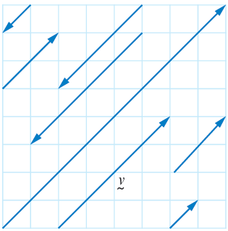
- On the grid, some parallel vectors are shown. Name each vector in terms of $\overset{̰}{v}$.

From the top left to bottom right:
$$-\frac{1}{4}\overset{̰}{v}$$
$$\frac{1}{2}\overset{̰}{v}$$
$$-\frac{3}{4}\overset{̰}{v}$$
$$-\overset{̰}{v}$$
$$2\overset{̰}{v}$$
$$\frac{1}{2}\overset{̰}{v}$$
$$\frac{1}{4}\overset{̰}{v}$$
- Given each set of vectors $\underset{∼}{a}$ and $\underset{∼}{b}$, draw:
 | - $\underset{∼}{a}+\underset{∼}{b}$ | - $\underset{∼}{a}-\underset{∼}{b}$
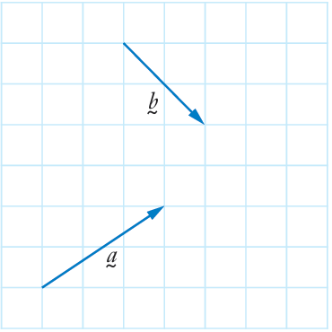

- Given each set of vectors $\underset{∼}{a}$ and $\underset{∼}{b}$, draw:
 | - $\underset{∼}{a}+\underset{∼}{b}$ | - $\underset{∼}{a}-\underset{∼}{b}$
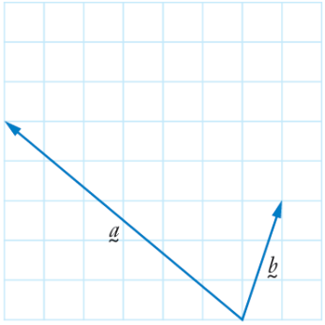

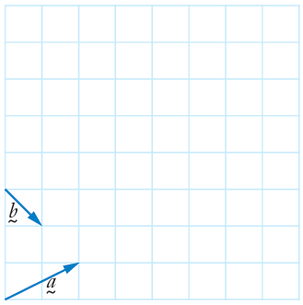
- Draw:

- $\underset{∼}{a}+\underset{∼}{b}$ |  |  |  |  |  |  |  |  |  |  |  |  | - $\underset{∼}{a}-\underset{∼}{b}$ |  |  |  |  |  |  |  |  |  |  |  |  | - $\underset{∼}{b}-\underset{∼}{a}$

- Draw a vector representing $\overset{̰}{b} - \overset{̰}{a}.$
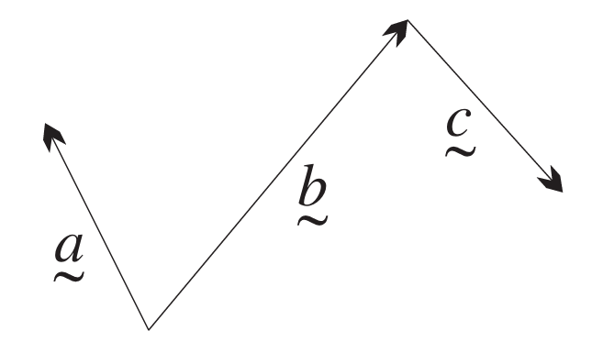
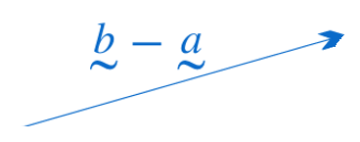

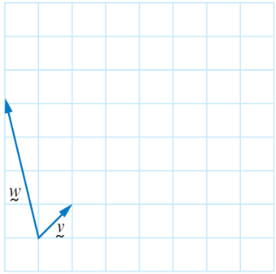
- Draw:

- $\underset{∼}{v}+\underset{∼}{w}$ |  |  |  |  |  |  |  |  |  |  |  |  | - $\underset{∼}{w}-\underset{∼}{v}$ |  |  |  |  |  |  |  |  |  |  |  |  | - $\underset{∼}{v}-\underset{∼}{w}$

- Write vector $\underset{∼}{c}$ in terms of $\underset{∼}{a}$ and $\underset{∼}{b}$ for each diagram.
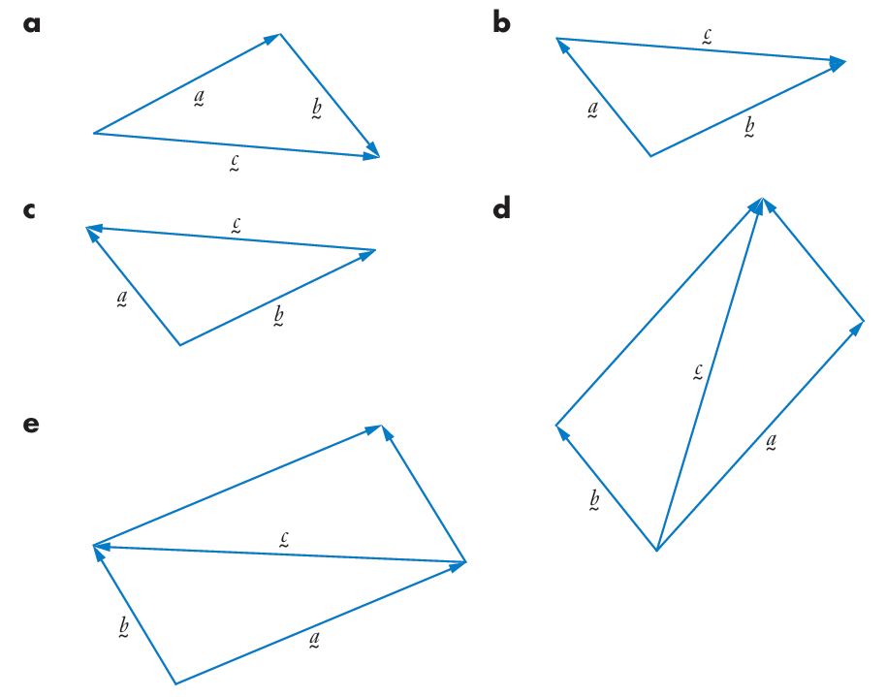  $$\underset{∼}{a}+\underset{∼}{b}$$ | $$\underset{∼}{b}-\underset{∼}{a}$$ | $$\underset{∼}{a}-\underset{∼}{b}$$
$\underset{∼}{a}+\underset{∼}{b}$ or $\overset{̰}{b}+\overset{̰}{a}$ | $\underset{∼}{b}-\underset{∼}{a}$ or $-\overset{̰}{a}+\overset{̰}{b}$

- Find the vector in the diagram that represents:
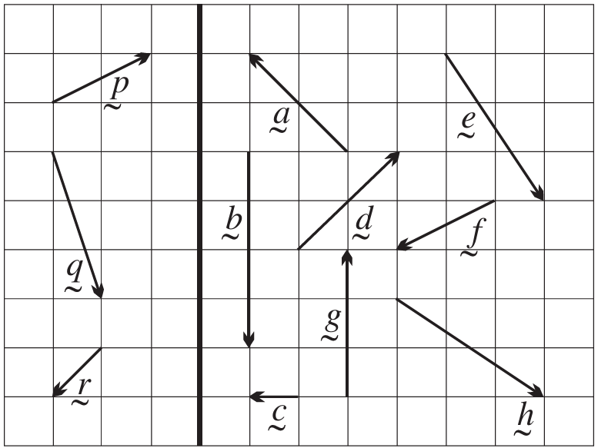
  - $-\overset{̰}{p}$
$$\overset{̰}{f}$$
  - $-2\overset{̰}{r}$
$$\overset{̰}{d}$$
  - $\overset{̰}{p}$ + $\overset{̰}{q}$
$$\overset{̰}{h}$$
  - $\overset{̰}{q}$ + $\overset{̰}{r}$
$$\overset{̰}{b}$$
  - $-\overset{̰}{p} - \overset{̰}{r}$
$$\overset{̰}{c}$$
  - $-\overset{̰}{q} + \overset{̰}{r}$
$$\overset{̰}{a}$$
  - $p ̰ + q ̰ + r ̰$
$$\overset{̰}{e}$$
  - $\overset{̰}{p} - \overset{̰}{q} + \overset{̰}{r}$
$$\overset{̰}{g}$$

Column Vector Notation

- Investigation vector components.
Every vector has a horizontal component and a vertical component.
This is the reverse process of vector addition, where we decompose a single vector into two perpendicular parts.
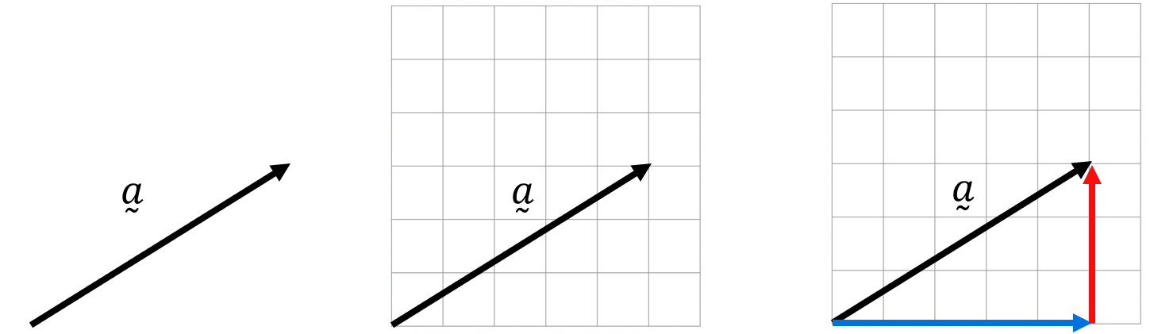

We can then describe this vector using column vector notation:

$$\overset{̰}{a}=\left(\begin{aligned}5 \\ 3\end{aligned}\right)$$

For $\left(\begin{aligned}5 \\ 3\end{aligned}\right)$, $5$ means to move 5 units ………… from tail to tip.
$3$ means to move 3 units ………… from tail to tip.

Express the following vectors in column notation:

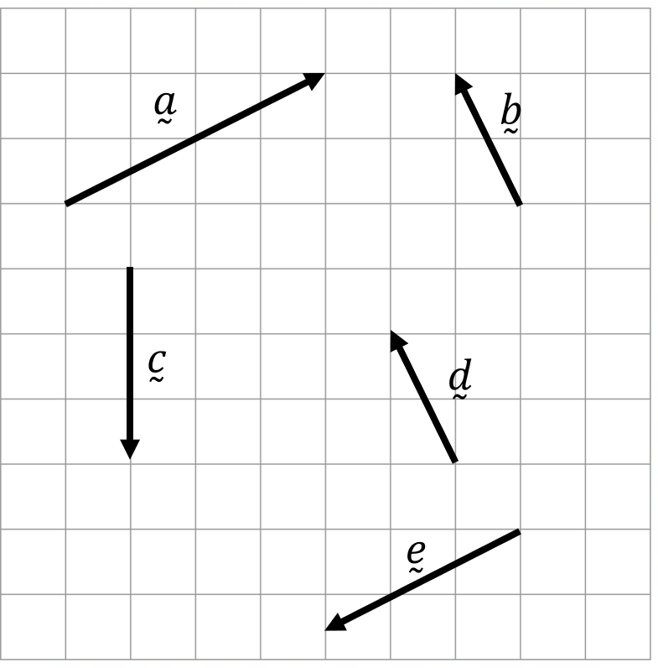
$\overset{̰}{a}=\left(\begin{aligned} \\ \end{aligned}\right)$

$\overset{̰}{b}=\left(\begin{aligned} \\ \end{aligned}\right)$

$\overset{̰}{c}=\left(\begin{aligned} \\ \end{aligned}\right)$

$\overset{̰}{d}=\left(\begin{aligned} \\ \end{aligned}\right)$

$\overset{̰}{e}=\left(\begin{aligned} \\ \end{aligned}\right)$

- Column Vector Notation
Every vector has a horizontal component and a vertical component.
We express this using column vector notation.
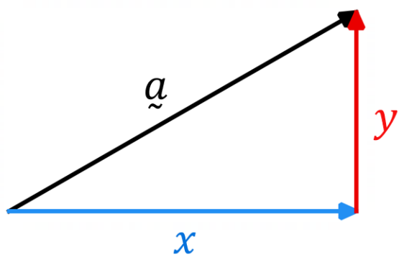
$\overset{̰}{a}=\left(\begin{aligned}x \\ y\end{aligned}\right)$

Positive means right / up.
Negative means left / down.

- It is also valid to write a vector as an ordered pair $\left(x,y\right)$,
but this might be confused for a point, so will be avoided in this booklet.

- Interpret column vector notation
For the vectors given below, sketch on the grid:
- $\overset{̰}{a}=\left(\begin{aligned}3 \\ 5\end{aligned}\right)$ |  |  |  |  |  |  |  |  | - $\overset{̰}{b}=\left(\begin{aligned}5 \\ 3\end{aligned}\right)$ |  |  |  |  |  |  |  |  | - $\overset{̰}{c}=\left(\begin{aligned}5 \\ -3\end{aligned}\right)$ |  |  |  |  |  |  |  |  | - $\overset{̰}{d}=\left(\begin{aligned}-5 \\ -3\end{aligned}\right)$
- $\overset{̰}{e}=\left(\begin{aligned}0 \\ 5\end{aligned}\right)$ |  |  |  |  |  |  |  |  | - $\overset{̰}{f}=\left(\begin{aligned}5 \\ 0\end{aligned}\right)$ |  |  |  |  |  |  |  |  | - $\overset{̰}{g}=\left(\begin{aligned}-5 \\ 0\end{aligned}\right)$ |  |  |  |  |  |  |  |  | - $\overset{̰}{h}=\left(\begin{aligned}-2 \\ 4\end{aligned}\right)$

- Investigation vector arithmetic using column vectors.
Vectors can be represented in two ways: as geometric arrows or as algebraic columns.
The algebraic form makes calculations easier.

Find $\overset{̰}{a}+\overset{̰}{b}$ and $\overset{̰}{c}+\overset{̰}{d}$ using geometric vector addition below:

$$\overset{̰}{c}$$
$$\overset{̰}{b}$$
$$\overset{̰}{d}$$
$$\overset{̰}{a}$$
Write using column notation:

$\overset{̰}{a}=\left(\begin{aligned} \\ \end{aligned}\right)$ $\overset{̰}{b}=\left(\begin{aligned} \\ \end{aligned}\right)$ $\overset{̰}{a}+\overset{̰}{b}=\left(\begin{aligned} \\ \end{aligned}\right)$

$\overset{̰}{c}=\left(\begin{aligned} \\ \end{aligned}\right)$ $\overset{̰}{d}=\left(\begin{aligned} \\ \end{aligned}\right)$ $\overset{̰}{c}+\overset{̰}{d}=\left(\begin{aligned} \\ \end{aligned}\right)$

What do you notice?

Find $2\overset{̰}{a}$ and $3\overset{̰}{b}$ below:

$$\overset{̰}{b}$$
$$\overset{̰}{a}$$
Write using column notation:

$\overset{̰}{a}=\left( \begin{aligned} \\ \end{aligned} \right)$ $2\overset{̰}{a}=\left( \begin{aligned} \\ \end{aligned} \right)$

$\overset{̰}{b}=\left( \begin{aligned} \\ \end{aligned} \right)$ $3\overset{̰}{b}=\left( \begin{aligned} \\ \end{aligned} \right)$

What do you notice?

- Column Vector Arithmetic
To add or subtract vectors, add or subtract each component separately.
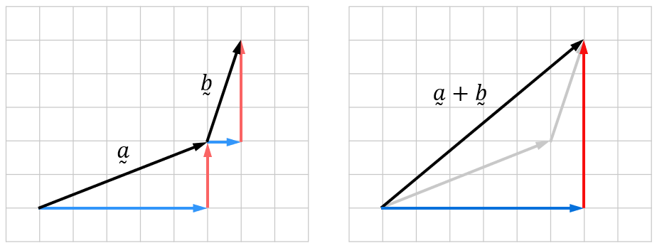
$\overset{̰}{a}=\left(\begin{aligned}x_{1} \\ y_{1}\end{aligned}\right)$
$\overset{̰}{b}=\left(\begin{aligned}x_{2} \\ y_{2}\end{aligned}\right)$
$$\overset{̰}{a}+\overset{̰}{b}=\left(\begin{aligned}x_{1}+x_{2} \\ y_{1}+y_{2}\end{aligned}\right)$$

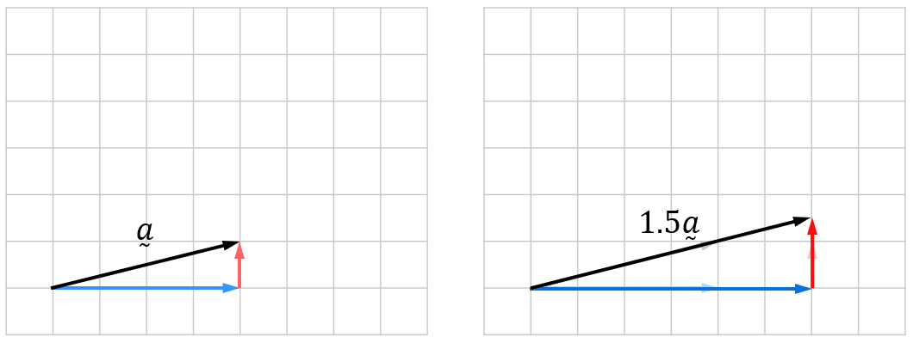
To multiply a vector by a scalar, multiply each component separately.

$\overset{̰}{a}=\left(\begin{aligned}x \\ y\end{aligned}\right)$
$λ\overset{̰}{a}=\left(\begin{aligned}λx \\ λy\end{aligned}\right)$

- Vector multiplication follows the distributive law: $λ\left(\overset{̰}{a}+\overset{̰}{b}\right)=λ\overset{̰}{a}+λ\overset{̰}{b}$

- Add and multiply vectors using column notation.
- $2\left(\begin{aligned}8 \\ -1\end{aligned}\right)=$  $3\left(\begin{aligned}8 \\ -1\end{aligned}\right)=$  $-3\left(\begin{aligned}8 \\ -1\end{aligned}\right)=$ | - $\left(\begin{aligned}1 \\ 5\end{aligned}\right)+\left(\begin{aligned}7 \\ 10\end{aligned}\right)=$  $$\left(\begin{aligned}10 \\ 5\end{aligned}\right)+\left(\begin{aligned}7 \\ 10\end{aligned}\right)=$$  $$\left(\begin{aligned}10 \\ 5\end{aligned}\right)+\left(\begin{aligned}7 \\ -10\end{aligned}\right)=$$ | - $\left(\begin{aligned}6 \\ 8\end{aligned}\right)+\left(\begin{aligned}1 \\ 13\end{aligned}\right)+\left(\begin{aligned}-2 \\ 0\end{aligned}\right)=$  $$\left(\begin{aligned}6 \\ 8\end{aligned}\right)+\left(\begin{aligned}1 \\ 13\end{aligned}\right)-\left(\begin{aligned}-2 \\ 0\end{aligned}\right)=$$
- $\left(\begin{aligned}2a \\ b\end{aligned}\right)+\left(\begin{aligned}-6a \\ 3a\end{aligned}\right)=$ | - $\frac{1}{5}$ $\left(\begin{aligned}15a \\ -10\end{aligned}\right)=$  $\frac{3}{4}$ $\left(\begin{aligned}-12 \\ 8\end{aligned}\right)=$ | - $2\left(\begin{aligned}6 \\ 8\end{aligned}\right)-3\left(\begin{aligned}1 \\ 5\end{aligned}\right)=$  $$2\left(\begin{aligned}6 \\ 8\end{aligned}\right)-3\left(\begin{aligned}1 \\ -5\end{aligned}\right)=$$

Foundation
- Find the resultant vector of:
- $\left(\begin{aligned}6 \\ -1\end{aligned}\right)+ \left(\begin{aligned}-2 \\ 4\end{aligned}\right)$  $$\left(\begin{aligned}4 \\ 3\end{aligned}\right)$$ | - $\left(\begin{aligned}2 \\ -1\end{aligned}\right)+ \left(\begin{aligned}-8 \\ -5\end{aligned}\right)$  $$\left(\begin{aligned}-6 \\ -6\end{aligned}\right)$$ | - $\left(\begin{aligned}0 \\ -2\end{aligned}\right)- \left(\begin{aligned}9 \\ 2\end{aligned}\right)$  $$\left(\begin{aligned}-9 \\ -4\end{aligned}\right)$$
- $\left(\begin{aligned}-4 \\ -5\end{aligned}\right)- \left(\begin{aligned}4 \\ -2\end{aligned}\right)$  $$\left(\begin{aligned}-8 \\ -3\end{aligned}\right)$$ | - $\left(\begin{aligned}2 \\ -5\end{aligned}\right)- \left(\begin{aligned}-1 \\ 6\end{aligned}\right)$  $$\left(\begin{aligned}3 \\ -11\end{aligned}\right)$$ | - $5\left(\begin{aligned}3 \\ 4\end{aligned}\right)$  $$\left(\begin{aligned}15 \\ 20\end{aligned}\right)$$
- $-3\left(\begin{aligned}6 \\ -2\end{aligned}\right)$  $$\left(\begin{aligned}-18 \\ 6\end{aligned}\right)$$ | - $\left(\begin{aligned}2 \\ 1\end{aligned}\right)+ \left(\begin{aligned}-1 \\ -3\end{aligned}\right)+ \left(\begin{aligned}4 \\ -5\end{aligned}\right)$  $$\left(\begin{aligned}5 \\ -7\end{aligned}\right)$$ | - $\left(\begin{aligned}-1 \\ -2\end{aligned}\right)+ 2\left(\begin{aligned}2 \\ -3\end{aligned}\right)- \left(\begin{aligned}1 \\ 1\end{aligned}\right)$  $$\left(\begin{aligned}2 \\ -9\end{aligned}\right)$$

- The resultant vector is $\left(\begin{aligned}-2 \\ 5\end{aligned}\right)$ when adding vectors $\left(\begin{aligned}a \\ 3\end{aligned}\right)$ and $\left(\begin{aligned}-5 \\ b\end{aligned}\right).$ Find the values of $a$ and $b$.

$$a = 3, b = 2$$
- The resultant vector of $-3\left(\begin{aligned}x \\ y\end{aligned}\right)$ is $\left(\begin{aligned}-12 \\ 39\end{aligned}\right).$ Evaluate $x$ and $y$.

$$x = 4, y = -13$$
- The resultant vector of $4\left(\begin{aligned}p \\ -2\end{aligned}\right)- 3\left(\begin{aligned}2 \\ q\end{aligned}\right)$ is $\left(\begin{aligned}14 \\ -8\end{aligned}\right).$ Evaluate $p$ and $q$.

$$p = 5, q = 0$$
- Given that $\underset{∼}{a}= \left(\begin{aligned}2 \\ -2\end{aligned}\right),\underset{∼}{b}= \left(\begin{aligned}-3 \\ -5\end{aligned}\right)$ and $\underset{∼}{c}= \left(\begin{aligned}24 \\ 8\end{aligned}\right)$,
find the values of $λ₁$ and $λ₂$ such that $\underset{∼}{c} =λ_{1}\underset{∼}{a} +λ_{2}\underset{∼}{b}.$
$$\underset{∼}{c}=λ_{1}\underset{∼}{a}+λ_{2}\underset{∼}{b} \\ \left(\begin{aligned}24 \\ 8\end{aligned}\right)= λ_{1}\left(\begin{aligned}2 \\ -2\end{aligned}\right)+ λ_{2}\left(\begin{aligned}-3 \\ -5\end{aligned}\right) \\ \left(\begin{aligned}24 \\ 8\end{aligned}\right)= \left(\begin{aligned}2λ_{1} - 3λ_{2} \\ -2λ_{1} - 5λ_{2}\end{aligned}\right) \\ 2λ₁ - 3λ₂ = 24 (1) \\ -2λ₁ - 5λ₂ = 8 (2) \\ Adding (1) and (2): \\ -8λ₂ = 32 \\ λ₂ = -4 \\ Substitute λ₂ = -4 into (1): \\ 2λ₁ - 3(-4) = 24 \\ 2λ₁ + 12 = 24 \\ λ₁ = 6$$

Parallel and Perpendicular Vectors

- Identify Parallel vectors
✖ | ✔ | ✔ | ✔ | ✖
Identify which of the following pairs of vectors are parallel.

- Identify Parallel vectors
✖  $$\left(\begin{aligned}3 \\ 5\end{aligned}\right) and \left(\begin{aligned}5 \\ 7\end{aligned}\right)$$ | ✔  $$\left(\begin{aligned}3 \\ 5\end{aligned}\right) and \left(\begin{aligned}6 \\ 10\end{aligned}\right)$$ | ✔  $$\left(\begin{aligned}3 \\ 5\end{aligned}\right) and \left(\begin{aligned}-6 \\ -10\end{aligned}\right)$$ | ✔  $$\left(\begin{aligned}3 \\ 5\end{aligned}\right) and \left(\begin{aligned}21 \\ 35\end{aligned}\right)$$ | ✖  $$\left(\begin{aligned}3 \\ 5\end{aligned}\right) and \left(\begin{aligned}21 \\ 34\end{aligned}\right)$$
Identify which of the following pairs of vectors are parallel.
$$\left(\begin{aligned}2 \\ 5\end{aligned}\right) and \left(\begin{aligned}16 \\ 40\end{aligned}\right)$$ | $$\left(\begin{aligned}7 \\ 10\end{aligned}\right) and \left(\begin{aligned}10 \\ 13\end{aligned}\right)$$ | $$\left(\begin{aligned}-3 \\ 4\end{aligned}\right) and \left(\begin{aligned}6 \\ -8\end{aligned}\right)$$ | $$\left(\begin{aligned}5 \\ -1\end{aligned}\right) and \left(\begin{aligned}10 \\ 2\end{aligned}\right)$$ | $$\left(\begin{aligned}12 \\ -9\end{aligned}\right) and \left(\begin{aligned}4 \\ -3\end{aligned}\right)$$
$$\left(\begin{aligned}1 \\ -1\end{aligned}\right) and \left(\begin{aligned}-1 \\ 1\end{aligned}\right)$$ | $$\left(\begin{aligned}2 \\ 5\end{aligned}\right) and \left(\begin{aligned}2a \\ 5a\end{aligned}\right)$$ | $$3\overset{̰}{a} and 5\overset{̰}{a}$$ | $$\frac{20}{7}\overset{̰}{a} and-\overset{̰}{a}$$ | $$7\overset{̰}{a} and 7\overset{̰}{b}$$

- Parallel Vectors
Two vectors $\overset{̰}{a}$ and $\overset{̰}{b}$ are parallel if they have the same direction or opposite directions.
In other words, one vector is a scalar multiple of the other.

$\overset{̰}{b}=λ\overset{̰}{a}$

- Example Determine whether two vectors are parallel.
Is $4\overset{̰}{a}+6\overset{̰}{b}$parallel to $10\overset{̰}{a}+15\overset{̰}{b}$?  $$4\overset{̰}{a}+6\overset{̰}{b}=2\left(2\overset{̰}{a}+3\overset{̰}{b}\right)$$  $$10\overset{̰}{a}+15\overset{̰}{b}=5\left(2\overset{̰}{a}+3\overset{̰}{b}\right)$$  Since both are scalar multiples of $2\overset{̰}{a}+3\overset{̰}{b}$, they are parallel. | Is $4\overset{̰}{a}+6\overset{̰}{b}$parallel to $5\overset{̰}{a}+15\overset{̰}{b}$?  $$4\overset{̰}{a}+6\overset{̰}{b}=2\left(2\overset{̰}{a}+3\overset{̰}{b}\right)$$  $$10\overset{̰}{a}+15\overset{̰}{b}=5\left(\overset{̰}{a}+3\overset{̰}{b}\right)$$  The two vectors are not scalar multiples of each other; they are not parallel.

- Guided Practice
Identify which of the following vectors are parallel.
- $3\overset{̰}{a}+7\overset{̰}{b}$and $9\overset{̰}{a}+21\overset{̰}{b}$  parallel | - $2\overset{̰}{b}-6\overset{̰}{a}$ and $6\overset{̰}{b}-24\overset{̰}{a}$  Not parallel
- $17\overset{̰}{a}+17\overset{̰}{b}$and $-10\overset{̰}{a}-10\overset{̰}{b}$  parallel | - $\overset{̰}{a}-\overset{̰}{b}$and $\overset{̰}{b}-\overset{̰}{a}$  parallel
- $4\overset{̰}{a}+6\overset{̰}{b}$and $6\overset{̰}{a}+8\overset{̰}{b}$  Not parallel | - $3\overset{̰}{a}-4\overset{̰}{b}$and $-9\overset{̰}{a}+12\overset{̰}{b}$  parallel
- $\overset{̰}{a}+\overset{̰}{b}+\overset{̰}{c}+\overset{̰}{d}$ and $\frac{\overset{̰}{a}+\overset{̰}{b}+\overset{̰}{c}+\overset{̰}{d}}{2}$  parallel | - $2\overset{̰}{a}-3\overset{̰}{b}-\overset{̰}{c}$ and $4\overset{̰}{a}+6\overset{̰}{b}+2\overset{̰}{c}$  Not parallel
- Perpendicular Vectors
Two vectors $\overset{̰}{a}$ and $\overset{̰}{b}$ are perpendicular if they are 90° to each other.
In column notation, components are swapped, and exactly one component changes sign.
This relates to gradients: perpendicular gradients are negative reciprocals of each other.
For a negative reciprocal, swap the numerator and denominator, and make one negative.
(If both are negative, the sign stays the same.)

$\left(\begin{aligned}x \\ y\end{aligned}\right)⊥\left(\begin{aligned}-y \\ x\end{aligned}\right) or \left(\begin{aligned}y \\ -x\end{aligned}\right)$

- Identify Perpendicular vectors
✖  $$\left(\begin{aligned}4 \\ 7\end{aligned}\right) and \left(\begin{aligned}7 \\ 4\end{aligned}\right)$$ | ✔  $$\left(\begin{aligned}4 \\ 7\end{aligned}\right) and \left(\begin{aligned}7 \\ -4\end{aligned}\right)$$ | ✔  $$\left(\begin{aligned}4 \\ 7\end{aligned}\right) and \left(\begin{aligned}-7 \\ 4\end{aligned}\right)$$ | ✖  $$\left(\begin{aligned}4 \\ 7\end{aligned}\right) and \left(\begin{aligned}-7 \\ -4\end{aligned}\right)$$
Identify which of the following pairs of vectors are perpendicular.
$$\left(\begin{aligned}3 \\ 8\end{aligned}\right) and \left(\begin{aligned}8 \\ -3\end{aligned}\right)$$ | $$\left(\begin{aligned}3 \\ -8\end{aligned}\right) and \left(\begin{aligned}8 \\ 3\end{aligned}\right)$$ | $$\left(\begin{aligned}3 \\ 8\end{aligned}\right) and \left(\begin{aligned}-3 \\ 8\end{aligned}\right)$$ | $$\left(\begin{aligned}-3 \\ -8\end{aligned}\right) and \left(\begin{aligned}3 \\ -8\end{aligned}\right)$$
$$\left(\begin{aligned}-1 \\ -6\end{aligned}\right) and \left(\begin{aligned}6 \\ 1\end{aligned}\right)$$ | $$\left(\begin{aligned}10 \\ -4\end{aligned}\right) and \left(\begin{aligned}-4 \\ -10\end{aligned}\right)$$ | $$\left(\begin{aligned}5 \\ -2\end{aligned}\right) and \left(\begin{aligned}2 \\ 5\end{aligned}\right)$$ | $$\left(\begin{aligned}-3 \\ 2\end{aligned}\right) and \left(\begin{aligned}3 \\ 2\end{aligned}\right)$$

- Perpendicular Vectors
Two vectors $\overset{̰}{a}$ and $\overset{̰}{b}$ are perpendicular if their components are swapped, and exactly one component changes sign.
Scalar multiples of perpendicular vectors remain perpendicular.

$\left(\begin{aligned}x \\ y\end{aligned}\right)⊥λ\left(\begin{aligned}-y \\ x\end{aligned}\right) or λ\left(\begin{aligned}y \\ -x\end{aligned}\right)$

Check if $\left(\begin{aligned}a \\ b\end{aligned}\right) \left(\begin{aligned}c \\ d\end{aligned}\right)$ is perpendicular by multiplying the components and see if they add to 0.
$$perpendicular if ac+bd=0$$

- Identify Perpendicular vectors involving scaling.
✔  $$\left(\begin{aligned}4 \\ 7\end{aligned}\right) and \left(\begin{aligned}-14 \\ 8\end{aligned}\right)$$ |  | ✔  $$\left(\begin{aligned}4 \\ 7\end{aligned}\right) and \left(\begin{aligned}3.5 \\ -2\end{aligned}\right)$$
Identify which of the following pairs of vectors are perpendicular.
$$\left(\begin{aligned}4 \\ 8\end{aligned}\right) and \left(\begin{aligned}4 \\ -2\end{aligned}\right)$$ | $$\left(\begin{aligned}-1 \\ -6\end{aligned}\right) and \left(\begin{aligned}7 \\ 42\end{aligned}\right)$$ |  | $$\left(\begin{aligned}-3 \\ 1\end{aligned}\right) and \left(\begin{aligned}6 \\ 2\end{aligned}\right)$$
$$\left(\begin{aligned}-10 \\ 4\end{aligned}\right) and \left(\begin{aligned}2 \\ 5\end{aligned}\right)$$ | $$\left(\begin{aligned}-6 \\ 4\end{aligned}\right) and \left(\begin{aligned}-20 \\ -30\end{aligned}\right)$$ |  | $$\left(\begin{aligned}35 \\ -21\end{aligned}\right) and \left(\begin{aligned}3 \\ 5\end{aligned}\right)$$

Foundation
- Determine which of the following pairs of vectors are parallel.
- $\left(\begin{aligned}2 \\ 3\end{aligned}\right) and \left(\begin{aligned}6 \\ 9\end{aligned}\right)$  parallel | - $\left(\begin{aligned}5 \\ 2\end{aligned}\right) and \left(\begin{aligned}10 \\ 5\end{aligned}\right)$  Not parallel | - $\left(\begin{aligned}-4 \\ 6\end{aligned}\right) and \left(\begin{aligned}2 \\ -3\end{aligned}\right)$  parallel
- $\left(\begin{aligned}7 \\ -3\end{aligned}\right) and \left(\begin{aligned}-14 \\ 6\end{aligned}\right)$  parallel | - $\left(\begin{aligned}9 \\ -6\end{aligned}\right) and \left(\begin{aligned}-3 \\ 2\end{aligned}\right)$  parallel | - $3\underset{∼}{a}+5\underset{∼}{b} and 6\underset{∼}{a}+10\underset{∼}{b}$  parallel
- $4\underset{∼}{u}-7\underset{∼}{v} and 8\underset{∼}{u}-15\underset{∼}{v}$  Not parallel | - $2\underset{∼}{a}+\underset{∼}{9b} and -\underset{∼}{8a}-\underset{∼}{36b}$  parallel | - $-\underset{∼}{c}+6\underset{∼}{d} and 3\underset{∼}{c}-18\underset{∼}{d}$  parallel

- Determine which of the following pairs of vectors are perpendicular.
- $\left(\begin{aligned}3 \\ 5\end{aligned}\right) and \left(\begin{aligned}5 \\ -3\end{aligned}\right)$  perpendicular | - $\left(\begin{aligned}7 \\ 2\end{aligned}\right) and \left(\begin{aligned}2 \\ 7\end{aligned}\right)$  Not perpendicular | - $\left(\begin{aligned}-4 \\ 9\end{aligned}\right) and \left(\begin{aligned}9 \\ 4\end{aligned}\right)$  perpendicular
- $\left(\begin{aligned}6 \\ -8\end{aligned}\right) and \left(\begin{aligned}8 \\ 6\end{aligned}\right)$  perpendicular | - $\left(\begin{aligned}-2 \\ -5\end{aligned}\right) and \left(\begin{aligned}-5 \\ 2\end{aligned}\right)$  perpendicular | - $\left(\begin{aligned}3 \\ -4\end{aligned}\right) and \left(\begin{aligned}8 \\ -6\end{aligned}\right)$  Not perpendicular
- $\left(\begin{aligned}-2 \\ 5\end{aligned}\right) and \left(\begin{aligned}15 \\ 6\end{aligned}\right)$  perpendicular | - $\left(\begin{aligned}6 \\ -9\end{aligned}\right) and \left(\begin{aligned}6 \\ 4\end{aligned}\right)$  perpendicular | - $\left(\begin{aligned}4 \\ -7\end{aligned}\right) and \left(\begin{aligned}-14 \\ 8\end{aligned}\right)$  Not perpendicular

- Show that the following vectors are parallel.
- $2\left(\begin{aligned}3 \\ 5\end{aligned}\right)and 3\left(\begin{aligned}2 \\ \frac{10}{3}\end{aligned}\right)$  $$2\left(\begin{aligned}3 \\ 5\end{aligned}\right)= \left(\begin{aligned}6 \\ 10\end{aligned}\right)$$  $$3\left(\begin{aligned}2 \\ \frac{10}{3}\end{aligned}\right)= \left(\begin{aligned}6 \\ 10\end{aligned}\right)$$ | - $\left(\begin{aligned}4 \\ -6\end{aligned}\right)+ \left(\begin{aligned}2 \\ -3\end{aligned}\right) and \left(\begin{aligned}12 \\ -18\end{aligned}\right)$  $$\left(\begin{aligned}4 \\ -6\end{aligned}\right)+ \left(\begin{aligned}2 \\ -3\end{aligned}\right)= \left(\begin{aligned}6 \\ -9\end{aligned}\right)$$  $$\left(\begin{aligned}12 \\ -18\end{aligned}\right)= 2\left(\begin{aligned}6 \\ -9\end{aligned}\right)$$ | - $3\left(\begin{aligned}2 \\ 7\end{aligned}\right)- \left(\begin{aligned}1 \\ 7\end{aligned}\right)and \left(\begin{aligned}10 \\ 28\end{aligned}\right)$  $$3\left(\begin{aligned}2 \\ 7\end{aligned}\right)- \left(\begin{aligned}1 \\ 7\end{aligned}\right)= \left(\begin{aligned}5 \\ 14\end{aligned}\right)$$  $$\left(\begin{aligned}10 \\ 28\end{aligned}\right)= 2\left(\begin{aligned}5 \\ 14\end{aligned}\right)$$

- Show that the following vectors are perpendicular.
- $-2\left(\begin{aligned}3 \\ 4\end{aligned}\right) and \left(\begin{aligned}8 \\ -6\end{aligned}\right)$  $$\left(-6\right)\left(8\right)+ \left(-8\right)\left(-6\right)= -48 + 48 = 0$$ | - $\left(\begin{aligned}5 \\ 2\end{aligned}\right)+ \left(\begin{aligned}1 \\ -3\end{aligned}\right) and \left(\begin{aligned}1 \\ 6\end{aligned}\right)$  $$\left(\begin{aligned}5 \\ 2\end{aligned}\right)+ \left(\begin{aligned}1 \\ -3\end{aligned}\right)= \left(\begin{aligned}6 \\ -1\end{aligned}\right)$$  $$\left(6\right)\left(1\right)+ \left(-1\right)\left(6\right)= 6 - 6 = 0$$ | - $\left(\begin{aligned}7 \\ -3\end{aligned}\right)- \left(\begin{aligned}2 \\ 1\end{aligned}\right) and \left(\begin{aligned}4 \\ 5\end{aligned}\right)$  $$\left(\begin{aligned}7 \\ -3\end{aligned}\right)- \left(\begin{aligned}2 \\ 1\end{aligned}\right)= \left(\begin{aligned}5 \\ -4\end{aligned}\right)$$  $$\left(5\right)\left(4\right)+ \left(-4\right)\left(5\right)= 20 - 20 = 0$$

- Find the value of $t$ such that the vectors are parallel.
- $2\left(\begin{aligned}3 \\ t\end{aligned}\right)and \left(\begin{aligned}9 \\ 12\end{aligned}\right)$  $$t=4$$ | - $\left(\begin{aligned}t \\ 4\end{aligned}\right)+ \left(\begin{aligned}2 \\ -1\end{aligned}\right)and \left(\begin{aligned}12 \\ 9\end{aligned}\right)$  $$t=2$$

- Find the value of $s$ such that the vectors are perpendicular.
- $2\left(\begin{aligned}3 \\ s\end{aligned}\right)and \left(\begin{aligned}4 \\ -6\end{aligned}\right)$  $$s=2$$ | - $\left(\begin{aligned}4 \\ -5\end{aligned}\right)and \left(\begin{aligned}s \\ 3\end{aligned}\right)+ \left(\begin{aligned}2 \\ 1\end{aligned}\right)$  $$s=3$$

- Given vectors $\underset{∼}{a}= \left(\begin{aligned}3 \\ -2\end{aligned}\right)$ and $\underset{∼}{b}= \left(\begin{aligned}1 \\ 4\end{aligned}\right):$
  - Find the value of $p$ such that $p\underset{∼}{a}+\underset{∼}{b}$is parallel to $\left(\begin{aligned}7 \\ 2\end{aligned}\right)$.
Remember that parallel means $p\underset{∼}{a}+\underset{∼}{b}=k\left(\begin{aligned}7 \\ 2\end{aligned}\right)$
$$p\underset{∼}{a}+\underset{∼}{b} = \left(\begin{aligned}3p+1 \\ -2p+4\end{aligned}\right)= k\left(\begin{aligned}7 \\ 2\end{aligned}\right) \\ 3p+1=7k (1) \\ -2p+4=2k (2) \\ rearranging \left(2\right): k=\frac{-2p+4}{2} \\ sub k into \left(1\right): 3p+1=\frac{7\left(-2p+4\right)}{2} \\ 2\left(3p+1\right)= 7\left(-2p+4\right) \\ 6p + 2 = -14p + 28 \\ 20p = 26 \\ p =\frac{13}{10}$$
  - Explain algebraically why the value of $p$ does not depend on the scalar multiple of $\left(\begin{aligned}7 \\ 2\end{aligned}\right)$.
In the solution above, the $k$ cancels, so $p$ is independent of $k$.
  - Explain this geometrically.
All scalar multiples of $\left(\begin{aligned}7 \\ 2\end{aligned}\right)$ represent the same direction.
Parallel vectors share the same direction regardless of magnitude, so $p$ depends only on direction, not the specific scalar multiple.
  - Find the value of $q$ such that $\underset{∼}{a} + q\underset{∼}{b}$is perpendicular to $\left(\begin{aligned}5 \\ 1\end{aligned}\right)$
$$\underset{∼}{a}+q\underset{∼}{b}= \left(\begin{aligned}3+q \\ -2+4q\end{aligned}\right)perpendicular to \left(\begin{aligned}5 \\ 1\end{aligned}\right) \\ Perpendicular if \left(\begin{aligned}1 \\ -5\end{aligned}\right)or \left(\begin{aligned}-1 \\ 5\end{aligned}\right) \\ Using \left(\begin{aligned}1 \\ -5\end{aligned}\right): 3+q = k \\ -2+4q = -5k \\ Substitute k = 3+q: \\ -2+4q = -5\left(3+q\right) \\ -2+4q = -15-5q \\ 9q = -13 \\ q = -\frac{13}{9} \\ Note that there is only one solution, even when you use the other case.$$

Component Form

- Basis Vectors
We can represent every vector using a horizontal component and a vertical component.
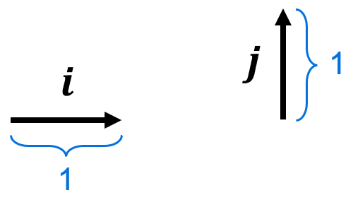
We define the horizontal unit vector $i=\left(\begin{aligned}1 \\ 0\end{aligned}\right)$ and the vertical unit vector $j=\left(\begin{aligned}0 \\ 1\end{aligned}\right)$.

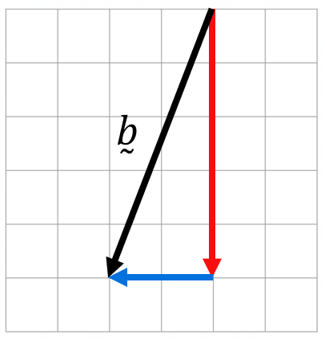
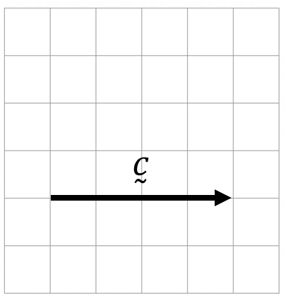
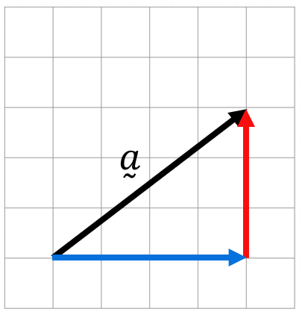
Every vector can be written as a sum of the unit vectors $i$ and $j$.

$\overset{̰}{a}=\left(\begin{aligned}4 \\ 3\end{aligned}\right)=4i+3j$ $\overset{̰}{b}=\left(\begin{aligned}-2 \\ -5\end{aligned}\right)=-2i-5j$ $\overset{̰}{c}=\left(\begin{aligned}4 \\ 0\end{aligned}\right)=4i$

- Interpret vectors in component form.
Write the following vectors in component notation.
- $\left(\begin{aligned}5 \\ 7\end{aligned}\right)$ | - $\left(\begin{aligned}-3 \\ 2\end{aligned}\right)$ | - $\left(\begin{aligned}62 \\ -35\end{aligned}\right)$
Write the following vectors in column notation.
- $4i+7j$ | - $9i-2j$ | - $6j+7i$
Sketch the following vectors.
- $-2i+5j$ | - $-3j+2i$ | - $ai$, where $a>0$

- Interpret vectors in component form.
For each vector, convert between the geometric representation, column notation, and component notation.
Geometric | Column Notation | Component Notation
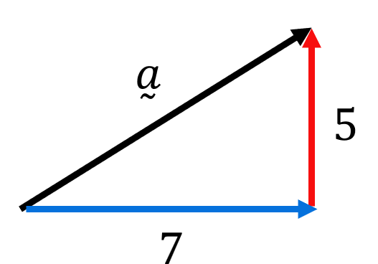

 | $$\left(\begin{aligned}5 \\ 7\end{aligned}\right)$$
 |  | $$5i-7j$$
 |  | $$5j-7i$$
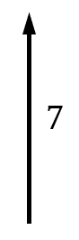

 | $$\left(\begin{aligned}7 \\ 0\end{aligned}\right)$$
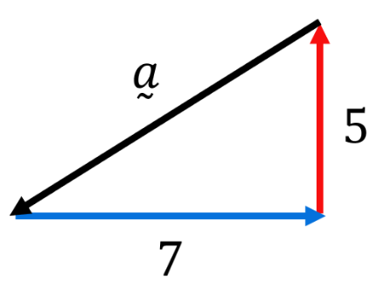

- Arithmetic with Vectors in Component Form
Just like column vector notation, to add or subtract vectors, add or subtract each component.
$\overset{̰}{a}=x_{1}i+y_{1}j$
$\overset{̰}{b}=x_{2}i+y_{2}j$
$$\overset{̰}{a}+\overset{̰}{b}=\left(x_{1}+x_{2}\right)i+\left(y_{1}+y_{2}\right)j$$
To multiply a vector by a scalar, multiply each component separately.
$$\overset{̰}{a}=xi+yj$$
$$λ\overset{̰}{a}=λ\left(xi+yj\right)$$
$=λxi+λyj$

- Example Operate with vectors in component form.
Given $\overset{̰}{a}=3i-2j$ and $\overset{̰}{b}=-4i-3j$, find these resultant vectors in component form:
$\overset{̰}{a}+\overset{̰}{b}$  $=\left(3i-2j\right)+\left(-4i-3j\right)$  $$=-i-5j$$ | $\overset{̰}{b}-\overset{̰}{a}$  $=\left(-4i-3j\right)-\left(3i-2j\right)$  $$=-7i-j$$ | $$3\overset{̰}{a}+\frac{\overset{̰}{b}}{2}$$  $$=3\left(3i-2j\right)+\frac{1}{2}\left(-4i-3j\right)$$  $$=7i-\frac{15}{2}j$$

- Guided Practice
Given $\overset{̰}{a}=5i+3j$ and $\overset{̰}{b}=-2i+4j$, find these resultant vectors in component form:
$\overset{̰}{a}+\overset{̰}{b}$  $$3i+7j$$ | $\overset{̰}{b}-\overset{̰}{a}$  $$-7i+j$$ |  | $$2\overset{̰}{a}+\frac{\overset{̰}{b}}{2}$$  $$9i+8j$$
Given $\overset{̰}{a}=-6i+j$, $\overset{̰}{b}=3i-5j$, $\overset{̰}{c}=i+j$, find these resultant vectors in component form:
- $\overset{̰}{a}-\overset{̰}{b}+\overset{̰}{c}$  $$-8i+7j$$ |  | - $\overset{̰}{b}-2\overset{̰}{a}$  $$15i-7j$$

Foundation
- Given $\overset{̰}{a}=2i+5j$ and $\overset{̰}{b}=3i+j$, find these resultant vectors in component form:
- $\overset{̰}{a}+\overset{̰}{b}$  $$5i + 6j$$ | - $\overset{̰}{a}-\overset{̰}{b}$  $$-i + 4j$$ | - $2\overset{̰}{a}+\overset{̰}{b}$  $$7i + 11j$$

  - For $\underset{∼}{u}= 2i + j$ and $\underset{∼}{v}= -i + 2j$, write $\underset{∼}{u},\underset{∼}{v}$ and $\underset{∼}{u}+\underset{∼}{v}$ as column vectors.
$$\left(\begin{aligned}1 \\ 3\end{aligned}\right)$$
  - For $\underset{∼}{a}= \left(\begin{aligned}3 \\ 2\end{aligned}\right)$and $\underset{∼}{b}= \left(\begin{aligned}4 \\ 1\end{aligned}\right),$ write $\underset{∼}{a},\underset{∼}{b}$ and $\underset{∼}{a}-\underset{∼}{b}$ in component form.

$$-i+j$$

- Given $\overset{̰}{a}=4i-2j$ and $\overset{̰}{b}=-i+3j$, find these resultant vectors in component form:
- $\overset{̰}{b}-\overset{̰}{a}$  $$-5i + 5j$$ | - $\overset{̰}{3a}-\overset{̰}{2b}$  $$14i - 12j$$
  - If $\overset{̰}{a}+k\overset{̰}{b}=2i+4j$
Find $k$.

$$a + kb = 2i + 4j \\ (4i - 2j) + k(-i + 3j) = 2i + 4j \\ 4i - 2j - ki + 3kj = 2i + 4j \\ (4 - k)i + (-2 + 3k)j = 2i + 4j \\ Equate i: 4 - k = 2, k = 2 \\ Equate j: -2 + 3k = 4, k=2$$

- Given $\overset{̰}{a} = 6i - j$ and $\overset{̰}{b} = -2i + 4j$, find the ratio $r:s$ if $r\overset{̰}{a}+s\overset{̰}{b}=0$

$$r\left(6i - j\right)+ s\left(-2i + 4j\right)= 0 \\ 6ri - rj - 2si + 4sj = 0 \\ \left(6r - 2s\right)i + \left(-r + 4s\right)j = 0 \\ Equate i: 6r - 2s = 0, \\ 6r = 2s, \\ \frac{r}{s}=\frac{1}{3} \\ r:s = 1:3$$

Calculating Magnitude and Direction

- Magnitude Notation
$\left|\overset{̰}{a}\right|$ represents the magnitude of a vector.

$\overset{̰}{a}$ if $\overset{̰}{a}=$ 8 m at 075°, then $\left|\overset{̰}{a}\right|=8$ m.

- Identify magnitude of a vector.
Find:
- $\left|\overset{̰}{a}\right|$ |  |  |  |  |  |  |  | - $\left|\vec{AB}\right|$ |  |  |  |  |  |  |  | - $\left|c\right|$ |  |  |  |  |  |  |  | - $\left|\overset{̰}{d}\right|$ |  |  |  |  |  |  |  | - $\left|\overset{̰}{e}\right|$
 |  |  |  |  |  |  |  |  |  |  |  |  |  |  |  |  |  |  |  |  |  |  |  |  | $$\overset{̰}{d}$$
 | $$\overset{̰}{a}$$ |  |  |  |  |  |  |  |  |  |  |  |  |  | $$c$$
 |  |  |  |  |  |  |  |  |  |  |  |  |  |  |  |  |  |  |  |  |  |  |  |  |  |  |  |  |  |  |  |  |  | $$\overset{̰}{e}$$
$$B$$
$$A$$

- Calculating Magnitude
The magnitude of a vector $\overset{̰}{a}=\left(\begin{aligned}x \\ y\end{aligned}\right)=xi+yj$ is:

$$\left|\overset{̰}{a}\right|=\sqrt{x^{2}+y^{2}}$$

- Calculate magnitude of a vector
- $\overset{̰}{a}=\left(\begin{aligned}3 \\ 1\end{aligned}\right)$  $\left|\overset{̰}{a}\right|=$ | - $\overset{̰}{a}=\left(\begin{aligned}-3 \\ 1\end{aligned}\right)$  $\left|\overset{̰}{a}\right|=$ | - $\overset{̰}{a}=2i+5j$
- $\overset{̰}{a}=-5i-2j$ | - $\overset{̰}{a}=1.5i+j$ | - $\overset{̰}{a}=-9j$

- Direction
Usually, the direction of a vector is stated as the angle of inclination from the positive $x$ axis.
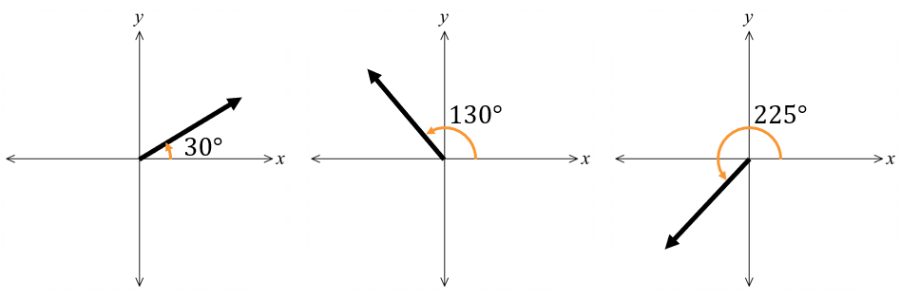

- In navigation scenarios, you may need to use true bearings instead of angle of inclination.

- Identify Direction of a vector
Draw the angle representing the direction of the vector.
Draw the angle representing the direction of the vector.

- Direction
Usually, the direction of a vector is stated as the angle of inclination from the positive $x$ axis. We use trigonometry to find the direction. A diagram is usually essential.
1. Draw a sketch of the vector, showing the horizontal and vertical components.
2. Label the reference angle and use trigonometry to calculate it:
$$A=\tan^{-1}\left(\frac{\left|y\right|}{\left|x\right|}\right)$$
3. Find the angle of inclination using angle relationships.

- In navigation scenarios, you may need to use true bearings instead of angle of inclination.

- Example Calculate the direction of a vector.
Find the direction of the vector $\overset{̰}{a}=5i-3j.$
Answer as an angle of inclination to the nearest degree.
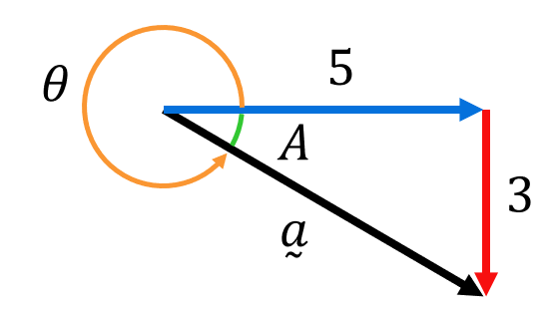  1. | 2.  $$A=\tan^{-1}\left(\frac{3}{5}\right)=31°$$ | 3.  $$∴θ=360-31$$  $$=329°$$

- Guided Practice
Find the direction of the vector. Answer as an angle of inclination to one decimal place.
- $\overset{̰}{a}=-3i+j$  $$161.6°$$ | - $\overset{̰}{a}=-2i-7j$  $$254.1°$$
Find the direction of the vector. Answer as a true bearing the nearest degree.
- $\overset{̰}{a}=3i-j$  $$108°$$ | - $\overset{̰}{a}=-2i+2j$  $$315°$$

Foundation
- Find the exact magnitude of each vector.
- $\left(\begin{aligned}-2 \\ 3\end{aligned}\right)$  $$\sqrt{13}$$ | - $\left(\begin{aligned}5 \\ 7\end{aligned}\right)$  $$\sqrt{74}$$ | - $\left(\begin{aligned}-9 \\ -7\end{aligned}\right)$  $$\sqrt{130}$$
- $\left(\begin{aligned}2 \\ 9\end{aligned}\right)$  $$\sqrt{85}$$ | - $\left(\begin{aligned}4 \\ -1\end{aligned}\right)$  $$\sqrt{17}$$

- Find the direction of each vector to the nearest degree.
- $\left(\begin{aligned}1 \\ 4\end{aligned}\right)$  $$76°$$ | - $\left(\begin{aligned}2 \\ 1\end{aligned}\right)$  $$27°$$ | - $\left(\begin{aligned}-2 \\ -5\end{aligned}\right)$  $$248°$$
- $\left(\begin{aligned}-1 \\ 3\end{aligned}\right)$  $$108°$$ | - $\left(\begin{aligned}6 \\ -2\end{aligned}\right)$  $$342°$$ | - $\left(\begin{aligned}-3 \\ 4\end{aligned}\right)$  $$127°$$

- If $\underset{∼}{a}= 8i + 6j$, find:
- $\left|\underset{∼}{a}\right|$  $$10$$ | - $2\underset{∼}{a}$  $$16i+12j$$ | - $\left|2\underset{∼}{a}\right|$  $$20$$
- $-5\underset{∼}{a}$  $$-40i-30j$$ | - $\left|-5\underset{∼}{a}\right|$  $$50$$

Development
- Find the magnitude and direction of each vector. Give your answers in exact form.
- $\underset{∼}{a}= 2i + 2j$  $$2\sqrt{2}, 45°$$ | - $\underset{∼}{b}= \left(\begin{aligned}1 \\ -\sqrt{3}\end{aligned}\right)$  $$2, 300°$$
- $\underset{∼}{c}= -3\sqrt{3}i+ 3j$  $$6, 150°$$ | - $\underset{∼}{d}= \left(\begin{aligned}-\sqrt{6} \\ -\sqrt{6}\end{aligned}\right)$  $$2\sqrt{3}, 225°$$

- Suppose that $\underset{∼}{a}= 2i + 3j$ and $\underset{∼}{b}= i - 4j$. Find:
- $\underset{∼}{a}+\underset{∼}{b}$  $$3i-j$$ | - $\left|\underset{∼}{a}+\underset{∼}{b}\right|$  $$\sqrt{10}$$ | - $\underset{∼}{a}-\underset{∼}{b}$  $$i+7j$$
- $\left|\underset{∼}{a}-\underset{∼}{b}\right|$  $$5\sqrt{2}$$ | - $-3\underset{∼}{a}-2\underset{∼}{b}$  $$-8i-j$$ | - $\left|-3\underset{∼}{a}-2\underset{∼}{b}\right|$  $$\sqrt{65}$$

- Vector $\underset{∼}{v}= ai + 3j$ has magnitude 5. Find the value of $a$.
$$\left|\underset{∼}{v}\right|= \sqrt{a^{2}+ 3^{2}}= 5 \\ a² + 9 = 25 \\ a² = 16 \\ a = ±4$$

- Vector $\underset{∼}{v}= 6i + bj$ has direction 45°. What is the value of $b$?
$$tan\left(45°\right)=\frac{b}{6} \\ 1 =\frac{b}{6} \\ b = 6$$

- Find the magnitude and direction of $\underset{∼}{x}+\underset{∼}{y}$ given that $\underset{∼}{x}= 5i + 3j$and $\underset{∼}{y}= -2i - 5j.$
Give magnitude in exact form and direction to the nearest degree.
$$\underset{∼}{x}+\underset{∼}{y}= \left(5i + 3j\right)+ \left(-2i - 5j\right)= 3i - 2j \\ \left|\underset{∼}{x}+\underset{∼}{y}\right|= \sqrt{3^{2}+ {\left(-2\right)}^{2}}= \sqrt{9 + 4}= \sqrt{13} \\ tan(θ) = -\frac{2}{3} \\ θ = tan^{-1}\left(-\frac{2}{3}\right)= -33.7° \\ Direction = 360° - 33.7° ≈ 326°$$

- Find the magnitude and direction of $\underset{∼}{b}-\underset{∼}{a}$if $\underset{∼}{a}= i + 7j$ and $\underset{∼}{b}= 4i - 9j$.
Give magnitude in exact form and direction to the nearest degree.
$$\underset{∼}{b}-\underset{∼}{a}= \left(4i - 9j\right)- \left(i + 7j\right)= 3i - 16j \\ \left|\underset{∼}{b}-\underset{∼}{a}\right|= \sqrt{3^{2}+ {\left(-16\right)}^{2}}= \sqrt{9 + 256}= \sqrt{265} \\ tan(θ) = -\frac{16}{3} \\ θ = tan^{-1}\left(-\frac{16}{3}\right)= -79.4° \\ Direction = 360° - 79.4° ≈ 281°$$

- Given $\underset{∼}{a}= \left(\begin{aligned}5 \\ -12\end{aligned}\right)$ and $\underset{∼}{b}= \left(\begin{aligned}-15 \\ -8\end{aligned}\right)$, show that:
- $\left|2\underset{∼}{a}\right|= 2\left|\underset{∼}{a}\right|$  $$\underset{∼}{a}= \left(\begin{aligned}5 \\ -12\end{aligned}\right) \\ \underset{∼}{2a}= \left(\begin{aligned}10 \\ -24\end{aligned}\right) \\ \left|\underset{∼}{2a}\right|= \sqrt{{10}^{2}+ {\left(-24\right)}^{2}} \\ = 26 \\ \left|\underset{∼}{a}\right|= \sqrt{5^{2}+ {\left(-12\right)}^{2}} \\ = 13 \\ LHS: \left|2\underset{∼}{a}\right|= 26 \\ RHS: 2\left|\underset{∼}{a}\right|= 2\left(13\right)= 26 \\ Hence, LHS = RHS.$$ | - $\left|-\underset{∼}{b}\right|= \left|\underset{∼}{b}\right|$  $$\underset{∼}{b}= \left(\begin{aligned}-15 \\ -8\end{aligned}\right) \\ -\underset{∼}{b}= \left(\begin{aligned}15 \\ 8\end{aligned}\right) \\ \left|-\underset{∼}{b}\right|= \sqrt{{15}^{2}+ 8^{2}} \\ = 17 \\ \left|\underset{∼}{b}\right| = \sqrt{{\left(-15\right)}^{2}+ {\left(-8\right)}^{2}} \\ = 17 \\ LHS: \left|-\underset{∼}{b}\right|= 17 \\ RHS: \left|\underset{∼}{b}\right|= 17 \\ Hence, LHS = RHS.$$
- $\left|\underset{∼}{a}+\underset{∼}{b}\right|< \left|\underset{∼}{a}\right|+ \left|\underset{∼}{b}\right|$  $$\underset{∼}{a}+\underset{∼}{b}= \left(\begin{aligned}5 + \left(-15\right) \\ \left(-12\right)+ \left(-8\right)\end{aligned}\right) \\ = \left(\begin{aligned}-10 \\ -20\end{aligned}\right) \\ \left|\underset{∼}{a}+\underset{∼}{b}\right|= \sqrt{{\left(-10\right)}^{2}+ {\left(-20\right)}^{2}} \\ = 5\sqrt{10} \\ \left|\underset{∼}{a}\right|= \sqrt{5^{2}+ {\left(-12\right)}^{2}} \\ = 13 \\ \left|\underset{∼}{b}\right|= \sqrt{{\left(-15\right)}^{2}+ {\left(-8\right)}^{2}} \\ = 17 \\ LHS: \left|\underset{∼}{a}+\underset{∼}{b}\right|= 5\sqrt{10}= 15.811… \\ RHS: \left|\underset{∼}{a}\right|+ \left|\underset{∼}{b}\right|= 13 + 17 = 30 \\ Hence, LHS < RHS.$$ | - $\left|\underset{∼}{a}+\underset{∼}{b}\right|> \left|\left|\underset{∼}{a}\right|- \left|\underset{∼}{b}\right|\right|$  $$LHS: \left|\underset{∼}{a}+\underset{∼}{b}\right|= 5\sqrt{10}= 15.811… \\ RHS:\left|\left|\underset{∼}{a}\right|- \left|\underset{∼}{b}\right|\right|=\left|13 - 17\right| = 4 \\ Hence, LHS > RHS.$$

Unit Vectors in a Particular Direction

- Unit Vector
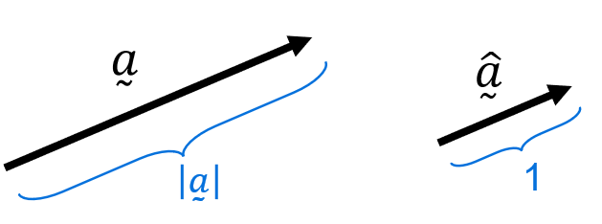
A unit vector is a vector that has a magnitude (length) of 1.
$\hat{\overset{̰}{a}}$ is the unit vector in the direction of $\overset{̰}{a}$.

- Identify the unit vector
The vector $\overset{̰}{a}$ is shown. Sketch the unit vector $\hat{a}$:
$$\left|\overset{̰}{a}\right|=2$$  $$\hat{\overset{̰}{a}}$$ | $$\left|\overset{̰}{a}\right|=3$$  $$\hat{\overset{̰}{a}}$$ |  | $$\left|\overset{̰}{a}\right|=2.5$$  $$\hat{\overset{̰}{a}}$$
The vector $\overset{̰}{b}$ is shown. Sketch the unit vector $\hat{b}$, given:
- $\left|\overset{̰}{b}\right|=3$ |  | - $\left|\overset{̰}{b}\right|=2$
- $\left|\overset{̰}{b}\right|=4$ |  | - $\left|\overset{̰}{b}\right|=2.5$

- Finding the Unit Vector
A unit vector is a vector that has a magnitude (length) of 1.
$\hat{\overset{̰}{a}}$ is the unit vector in the direction of $\overset{̰}{a}$.
To find $\hat{\overset{̰}{a}}:$
1. Find the magnitude of $\overset{̰}{a}: \left|\overset{̰}{a}\right|$
2. Divide $\overset{̰}{a}$ by its magnitude.
$$\hat{\overset{̰}{a}}=\frac{\overset{̰}{a}}{|\overset{̰}{a}|}$$

- Example Find unit vector in a given direction.
$\overset{̰}{a}=-7i-3j$. Find the unit vector in the same direction: $\hat{\overset{̰}{a}}$
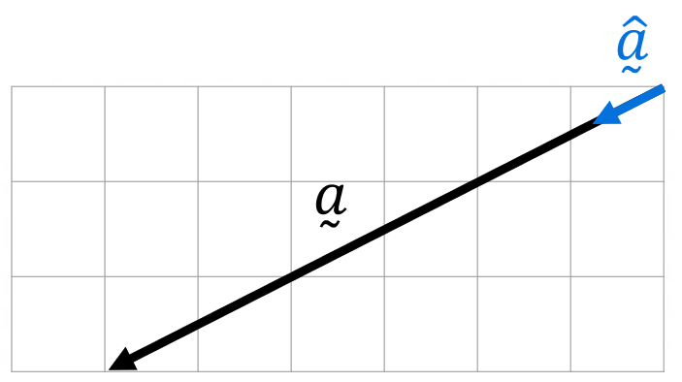
1.
$$\left|\overset{̰}{a}\right|=\sqrt{{\left(-7\right)}^{2}+{\left(-3\right)}^{2}}=\sqrt{58}$$
2.
$$\hat{\overset{̰}{a}}=\frac{\overset{̰}{a}}{|\overset{̰}{a}|}=\frac{\left(-7i-3j\right)}{\sqrt{58}}=\frac{1}{\sqrt{58}}\left(-7i-3j\right)$$

- Guided Practice
$\overset{̰}{a}=5i-8j$. Find the unit vector in the same direction: $\hat{\overset{̰}{a}}$

$$\frac{1}{\sqrt{89}}\left(5i-8j\right)$$
$\overset{̰}{a}=-2i+9j$. Find the unit vector in the same direction: $\hat{\overset{̰}{a}}$

$$\frac{1}{\sqrt{85}}\left(-2i+9j\right)$$

Foundation
- Find the unit vector $\hat{\overset{̰}{a}}$ if:
- $\underset{∼}{a}= 3i + 4j$  $$\frac{1}{5}\left(3i + 4j\right)$$ | - $\underset{∼}{a}= 5i - 12j$  $$\frac{1}{13}\left(5i - 12j\right)$$ | - $\underset{∼}{a}= -6i + 8j$  $$\frac{1}{10}\left(-6i + 8j\right)$$

- If $\underset{∼}{u}= i + 2j,\underset{∼}{v}= -4i + 3j$ and $\underset{∼}{w}=\underset{∼}{u}+\underset{∼}{v},$ find:
- $\underset{∼}{\hat{u}}$  $$\frac{1}{\sqrt{5}}i+\frac{2}{\sqrt{5}}j$$ | - $\underset{∼}{\hat{v}}$  $$-\frac{4}{5}i+\frac{3}{5}j$$ | - $\underset{∼}{\hat{w}}$  $$-\frac{3}{\sqrt{34}}i+\frac{5}{\sqrt{34}}j$$

- The unit vector in the direction of $\underset{∼}{a}$ is $\frac{3}{5}i +\frac{4}{5}j$. Find the vector $\underset{∼}{a}$ if $|\overset{̰}{a}| = 10$.

$$\underset{∼}{a}=\left|\overset{̰}{a}\right|×\hat{\overset{̰}{a}}= 10\left(\frac{3}{5}i +\frac{4}{5}j\right)= 6i + 8j$$
- $\underset{∼}{a} = ki + 3j$ where $k > 0$. If $|\overset{̰}{a}| = 5$, find the unit vector in the same direction $\hat{\overset{̰}{a}}$.
$$|\overset{̰}{a}|² = k² + 9 = 25 \\ k^{2}= 16, \\ k = 4 (since k > 0) \\ \underset{∼}{a} = 4i + 3j \\ \underset{∼}{â} =\frac{1}{5}(4i + 3j)$$

Point to Point Notation

- Vector Point-to-Point Notation
We can communicate the following vector quantity in these ways:
Magnitude & direction: 3 cm northeast OR
3 cm at angle of inclination $45°$
Variable notation: $\overset{̰}{a}$, $a$, or $\vec{a}$
Point-to-point notation: $\vec{PQ}$ (but not $\vec{QP}$)

- Interpret point-to-point notation
Label these vectors using $\vec{PQ}$ notation.
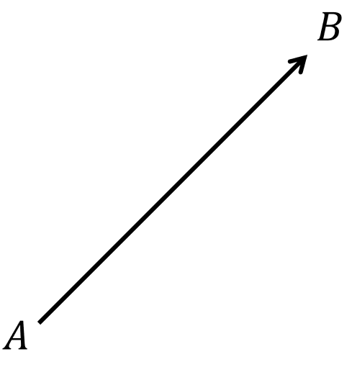
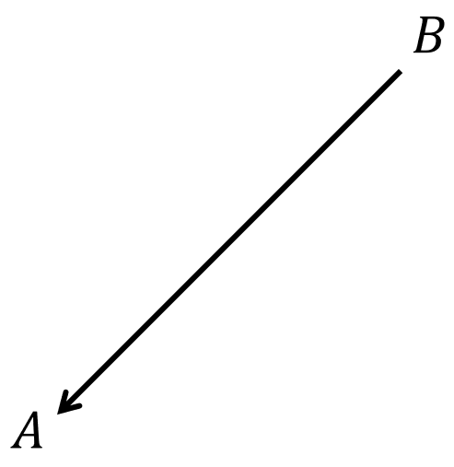
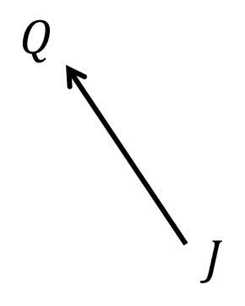
Sketch these vectors on the grid below:
$$\vec{AB}$$ |  |  |  |  |  |  |  |  | $$\vec{BA}$$ |  |  |  |  |  |  |  |  | $$Z$$  $$\vec{AZ}$$ |  |  |  |  |  |  |  |  | $$\vec{ZC}$$
 |  |  |  | $A$A
 |  |  |  |  |  |  |  |  |  |  |  |  |  |  |  |  | $$C$$
 |  |  |  |  |  |  |  |  |  |  | $B$A

- Example Interpret point-to-point notation.
$PQRS$ is a parallelogram where $\vec{PQ}=\overset{̰}{a}$ and $\vec{QR}=\overset{̰}{b}$.
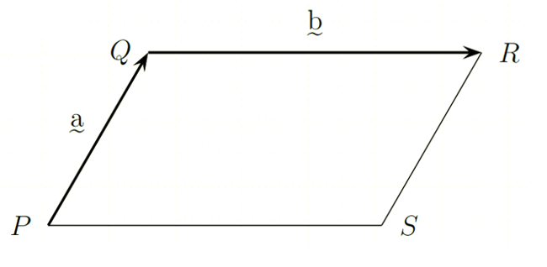

Find expressions in terms of $\overset{̰}{a}$ and $\overset{̰}{b}$ for:
- $\vec{QP}=-\overset{̰}{a}$ | - $\vec{SR}=\overset{̰}{a}$ | - $\vec{PR}=\overset{̰}{a}+\overset{̰}{b}$
- $\vec{RQ}=-\overset{̰}{b}$ | - $\vec{SP}=-\overset{̰}{b}$ | - $\vec{RP}=-\overset{̰}{a}-\overset{̰}{b}$

- Guided Practice
$PQRSTU$ is a regular hexagon. $\vec{PQ}=\overset{̰}{a}$ and $\vec{QR}=\overset{̰}{b}$,
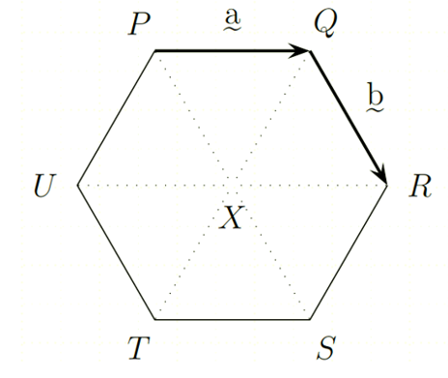

Find in terms of $\overset{̰}{a}$ and $\overset{̰}{b}:$
- $\vec{PX}$  $$\overset{̰}{b}$$ | - $\vec{SP}$  $$-2\overset{̰}{b}$$ | - $\vec{QX}$  $$\overset{̰}{b}-\overset{̰}{a}$$ | - $\vec{SR}$  $$\overset{̰}{a}-\overset{̰}{b}$$

- Guided Practice
$ABC$ is a triangle where $\vec{AB}=\overset{̰}{p}$ and $\vec{BC}=2\overset{̰}{p}-\overset{̰}{q}$.
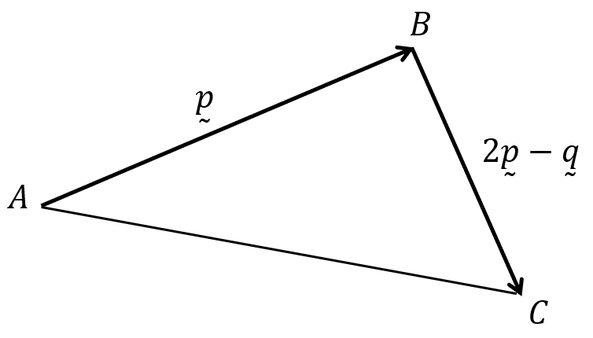

Find expressions in terms of $\overset{̰}{p}$ and $\overset{̰}{q}$ for:
- $\vec{BA}$  $$-\overset{̰}{p}$$ | - $\vec{CB}$  $$-2\overset{̰}{p}+\overset{̰}{q}$$ | - $\vec{AC}$  $$3\overset{̰}{p}-\overset{̰}{q}$$ |  | - $\vec{CA}$  $$-3\overset{̰}{p}+\overset{̰}{q}$$
- Important Vector Laws
The following laws are useful for solving geometrical problems:
Commutative Law  $$\overset{̰}{a}+\overset{̰}{b}=\overset{̰}{b}+\overset{̰}{a}$$ | 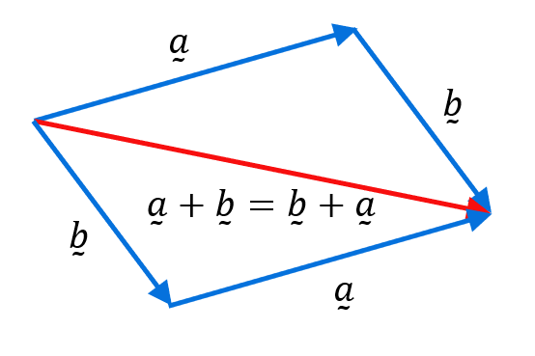 |  | You can add vectors in any order.
Negative Vector Law  $\vec{AB}=-\vec{BA}$ | 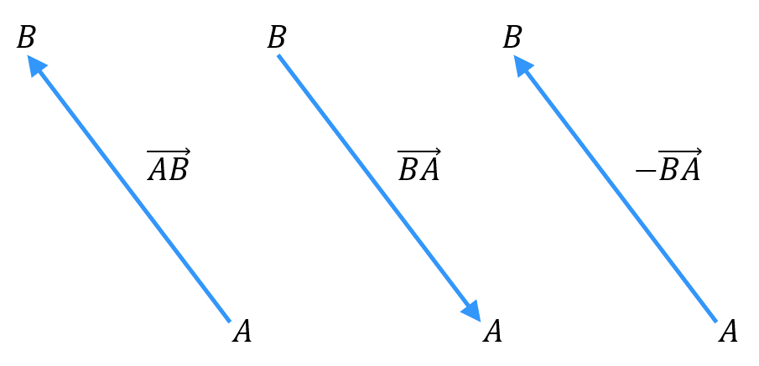 |  | Reversing a vector exchanges its tip and tail.
Triangle Law of Addition  $$\vec{AB}+\vec{BC}=\vec{AC}$$ | 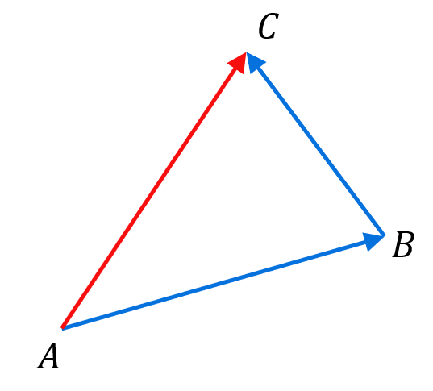 |  | When two vectors are placed head-to-tail, the resultant vector connects the tail of the first vector to the head of the second vector.
Parallelogram Law of Subtraction  $$\vec{AB}-\vec{AD}=\vec{DB}$$ | 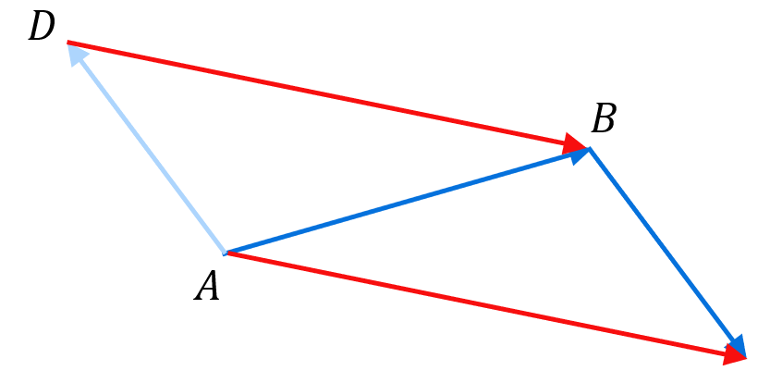 |  | The difference between two vectors equals the vector from the head of the second vector to the head of the first vector.

- Interpret Triangle and parallelogram laws
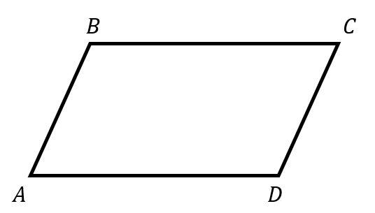
Find expressions using the laws, then confirm your answer using the parallelogram diagram.
- $\vec{AB}$ $+$ $\vec{BC}$  $=$ ……… | - $\vec{AC}+\vec{CB}$  $=$ ………
- $\vec{AC}-\vec{AB}$  $=$ ……… | - $\vec{AD}-\vec{AB}$  $=$ ………
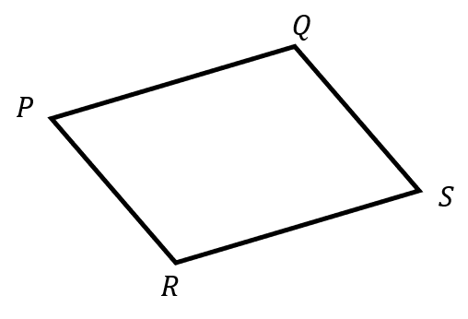
- $\vec{PQ}$ $+$ $\vec{QS}$  $=$ ……… | - $\vec{QR}+\vec{RS}$  $=$ ………
- $\vec{PS}-\vec{PQ}$  $=$ ……… | - $\vec{SR}-\vec{SQ}$  $=$ ………

- Example Apply algebraic vector laws
Prove that:
$$\vec{PR}-\vec{QR}+\vec{QS}=\vec{PS}$$  $$LHS=\vec{PR}+\vec{RQ}+\vec{QS} (-\vec{QR}=\vec{RQ}) \\ =\vec{PQ}+\vec{QS} (Δ law) \\ =\vec{PS} (Δ law) \\ =RHS$$ | $$\vec{EG}-\vec{EF}-\vec{GF}=2\vec{FG}$$  $$LHS=\vec{FG}-\vec{GF} (▱ law) \\ =\vec{FG}+\vec{FG} (-\vec{GF}=\vec{FG}) \\ =2\vec{FG} \\ =RHS$$

- Guided Practice
Prove that:
- $\vec{AB}-\vec{CB}+\vec{CD}=\vec{AD}$ | - $\vec{PT}-\vec{PR}-\vec{TR}=2\vec{RT}$
- $\vec{OQ}-\vec{OP}+\vec{QR}-\vec{SR}=\vec{PS}$ | - $\vec{GH}-\vec{FE}-\vec{EH}+\vec{FG}=\overset{̰}{0}$

Foundation
- Given parallelogram ABCD, write the vector that is:
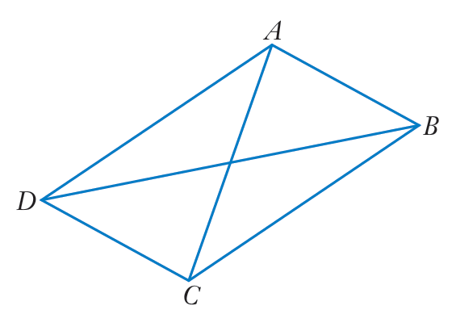 | - $\vec{AB} + \vec{BC}$  $$\vec{AC}$$ | - $\vec{AD} + \vec{DB}$  $$\vec{AB}$$
 | - $\vec{DC} + \vec{CA}$  $$\vec{DA}$$ | - $\vec{CD} + \vec{CB}$  $$\vec{CA}$$
 | - $\vec{DA} - \vec{AB}$  $$\vec{CA}$$ | - $\vec{AB} - \vec{AD}$  $$\vec{DB}$$
- $\vec{BC} - \vec{CD}$
$$\vec{AC}$$

- For the diagram, state the resultant vector of:
 | - $\vec{AB} + \vec{BG}$  $$\vec{AG}$$ | - $\vec{GE} + \vec{EF}$  $$\vec{GF}$$
 | - $\vec{BG} - \vec{CG}$  $$\vec{BC}$$ | - $\vec{GC} - \vec{BC}$  $$\vec{GB}$$
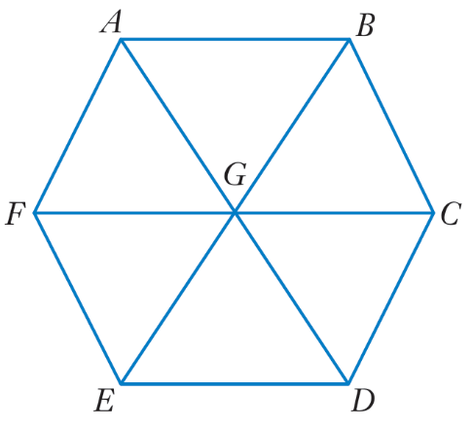 | - $\vec{GE} + \vec{EF} + \vec{FA}$  $$\vec{GA}$$

- For the diagram, state the resultant vector of:
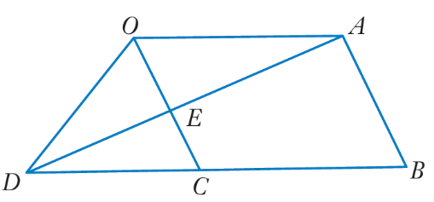 | - $\vec{AD} + \vec{DO}$  $$\vec{AO}$$ | - $\vec{DE} + \vec{EC}$  $$\vec{DC}$$
 | - $\vec{AE} - \vec{AO}$  $$\vec{OE}$$ | - $\vec{DB} - \vec{DA}$  $$\vec{AB}$$
- $\vec{AE} - \vec{AC}$
$$\vec{CE}$$

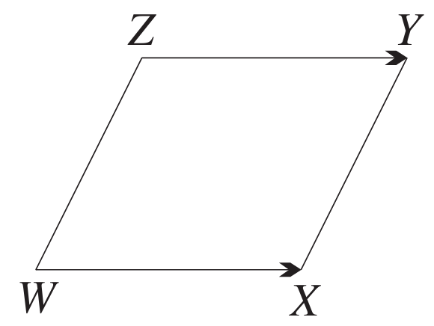
- In the diagram, $\vec{WX} = \vec{ZY}$. Explain why WXYZ is a parallelogram.

Since vectors $\vec{WX}$ and $\vec{ZY}$ are equal, the opposite sides WX and ZY are parallel and the same length, so WXYZ is a parallelogram.

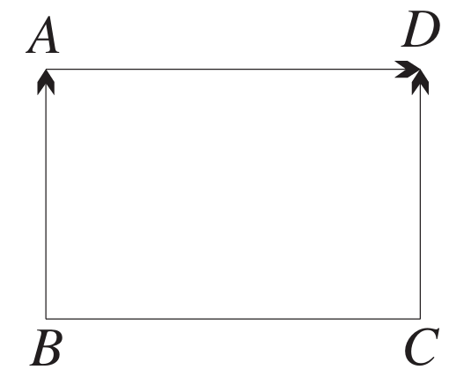
- In the diagram, $\vec{BA} = \vec{CD}$ and $\vec{BA} ⊥ \vec{AD}$.
What type of special quadrilateral is ABCD? Give reasons for your answer.

The opposite sides BA and CD are parallel and equal, and ∠BAD = 90°.
So ABCD is a parallelogram with an interior angle of 90°, so it is a rectangle

- In the diagram, $\vec{PQ}$, $\vec{QR}$, $\vec{RS}$ and $\vec{SP}$ all have the same magnitude.
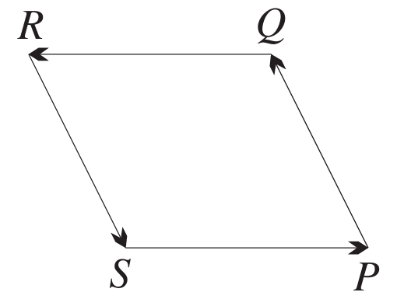
  - What type of special quadrilateral is PQRS?
Justify your answer.

The 4 sides are equal, so PQRS is a rhombus.
  - What can be said about the directions of $\vec{PQ}$ and $\vec{RS}$?
Justify your answer.

The opposite sides of a rhombus are parallel, so $\vec{PQ}$ and $\vec{RS}$have opposite directions.
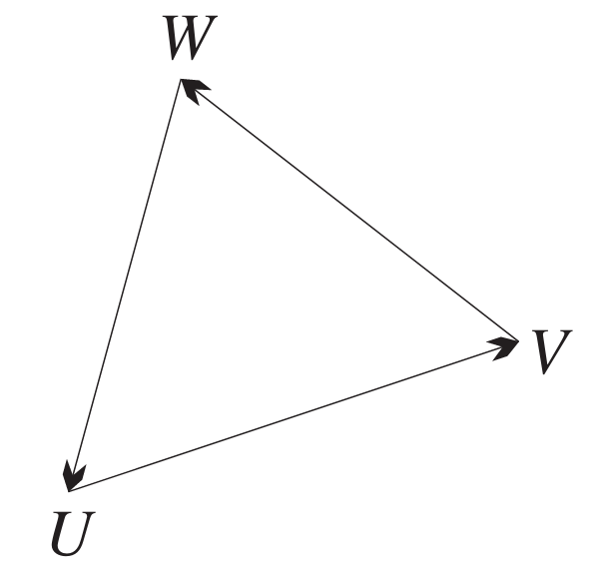
- In the diagram, what is $\vec{UV} + \vec{VW} + \vec{WU}$?

$$\overset{̰}{0}$$
- From the diagram, write down a single vector equal to:
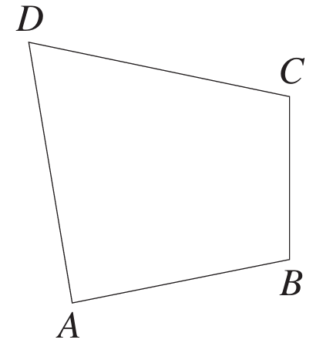
  - $\vec{AC} + \vec{CD}$
$$\vec{AD}$$
  - $\vec{BC} + \vec{CA}$
$$\vec{BA}$$
  - $\vec{AD} - \vec{AB}$
$$\vec{BD}$$
  - $\vec{\left(AC\right)} - \vec{BC}$
$$\vec{AB}$$

Development
- In each part, draw a diagram showing the displacement vector $\vec{AC}$. Then calculate the magnitude and direction of $\vec{AC}$. Give magnitude correct to the nearest km where necessary, and direction as a true bearing correct to the nearest degree where necessary.
- Sarah drives 100 km east from A to B,  and then 40 km west from B to C.  60 km, 090°T | - William walks 6 km south from A to B,  and then 4 km east from B to C.  7 km, 146°T | - A boat sails 25 km east from A to B,  and then 15 km northeast from B to C.  37 km, 073°T

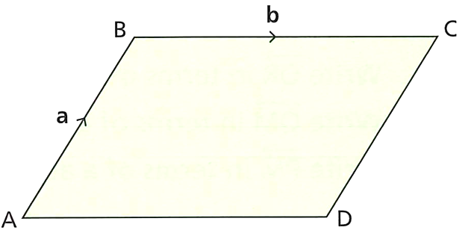
- ABCD is a parallelogram. Which statements are true?
$\vec{AB} = \vec{DC} | \vec{BC} = \vec{DA} | \vec{AD} = \vec{BC} | \vec{AC} = \vec{DB}$

$\vec{AB} = \vec{DC}, \vec{AD} = \vec{BC}$
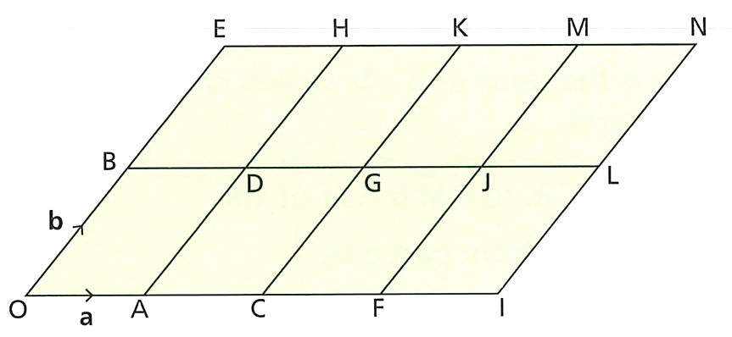
- On the grid of congruent parallelograms, $\vec{OA} =\underset{∼}{a} and \vec{OB} =\underset{∼}{b}.$

Write these vectors in terms of $\underset{∼}{a} and \underset{∼}{b}.$
- $\vec{OA}$  $$\overset{̰}{a}$$ | - $\vec{OB}$  $$\overset{̰}{b}$$ | - $\vec{OE}$  $$2\overset{̰}{b}$$ | - $\vec{OF}$  $$3\overset{̰}{a}$$
- $\vec{OD}$  $$\overset{̰}{a}+\overset{̰}{b}$$ | - $\vec{OH}$  $$\overset{̰}{a}+2\overset{̰}{b}$$ | - $\vec{HJ}$  $$2\overset{̰}{a}-\overset{̰}{b}$$ | - $\vec{JA}$  $$-2\overset{̰}{a}-\overset{̰}{b}$$

Mastery
- Prove the following. Show your steps clearly and state the laws used.
- $\vec{PQ} - \vec{RQ} + \vec{RS} = \vec{PS}$  $$= \vec{PQ} + \vec{QR} + \vec{RS} (negative vector)$$  $$= \vec{PR} + \vec{RS} (triangle law)$$  $$= \vec{PS} \left(triangle law\right)$$ | - $\vec{AB} - \vec{CB} + \vec{CD} = \vec{AD}$  $$= \vec{AB} + \vec{BC} + \vec{CD} (negative vector)$$  $$= \vec{AC} + \vec{CD} (triangle law)$$  $$= \vec{AD} (triangle law)$$
- $\vec{OM} - \vec{ON} + \vec{NM} = 2\vec{NM}$  $$= \vec{NM} + \vec{NM} (parallelogram law of subtraction)$$  $$= 2\vec{NM}$$ | - $\vec{PR} - \vec{QR} + \vec{QS} = \vec{PS}$  $$= \vec{PR} + \vec{RQ} + \vec{QS} (negative vector)$$  $$= \vec{PQ} + \vec{QS} (triangle law)$$  $$= \vec{PS} (triangle law)$$
- $\vec{EG} - \vec{EF} - \vec{GF} = 2\vec{FG}$  $$= \vec{FG} - \vec{GF} (parallelogram law of subtraction)$$  $$= \vec{FG} + \vec{FG} (negative vector)$$  $$= 2\vec{FG}$$ | - $\vec{PT} - \vec{PR} - \vec{TR} = 2\vec{RT}$  $$= \vec{RT} - \vec{TR} (parallelogram law of subtraction)$$  $$= \vec{RT} + \vec{RT} (negative vector)$$  $$= 2\vec{RT}$$
- $\vec{MN} - \vec{PN} + \vec{LM} = \vec{LP}$  $$= \vec{MN} + \vec{NP} + \vec{LM} (negative vector)$$  $$= \vec{LM} + \vec{MN} + \vec{NP} (commutative law)$$  $$= \vec{LN} + \vec{NP} (triangle law)$$  $$= \vec{LP} (triangle law)$$ | - $\vec{AB} - \vec{CB} - \vec{DC} - \vec{ED} = \vec{AE}$  $$= \vec{AB} + \vec{BC} + \vec{CD} + \vec{DE} (negative vector)$$  $$= \vec{AC} + \vec{CD} + \vec{DE} (triangle law)$$  $$= \vec{AD} + \vec{DE} (triangle law)$$  $$= \vec{AE} (triangle law)$$
- $\vec{BC} - \vec{BA} - \vec{DC} - \vec{AD} = \overset{̰}{0}$  $$= \vec{BC} + \vec{AB} + \vec{CD} + \vec{DA} (negative vector)$$  $$= \vec{AB} + \vec{BC} + \vec{CD} + \vec{DA} (commutative law)$$  $$= \vec{AC} + \vec{CD} + \vec{DA} (triangle law)$$  $$= \vec{AD} + \vec{DA} (triangle law)$$  $$= \overset{̰}{0} (zero vector)$$ | - $-\vec{XZ}+ \vec{XY} + \vec{ZY} = 2\vec{ZY}$  $$= \vec{XY} - \vec{XZ} + \vec{ZY} (commutative law)$$  $$= \vec{ZY} + \vec{ZY} (parallelogram law of subtraction)$$  $$= 2\vec{ZY}$$

Position Vectors

- Position Vectors
Two vectors with the same magnitude and direction are equal, regardless of starting point.
To simplify calculations, we can move the vector so that its tail is at the origin.
This creates a position vector.

“Free” Vectors  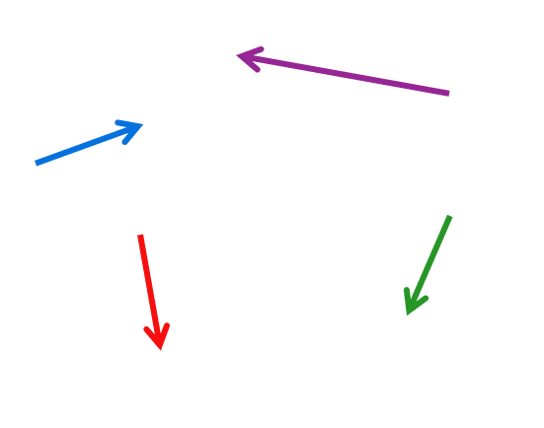 | 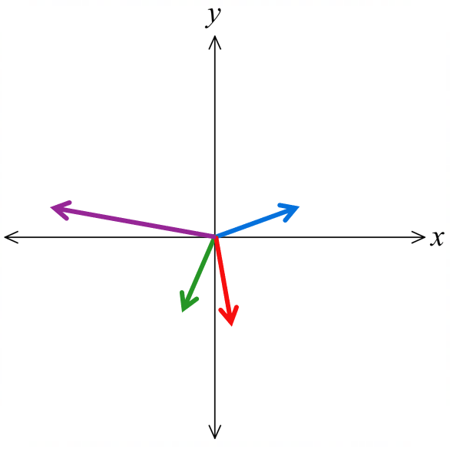  Position Vectors

- Identify position vectors.
Identify which of the following are position vectors.
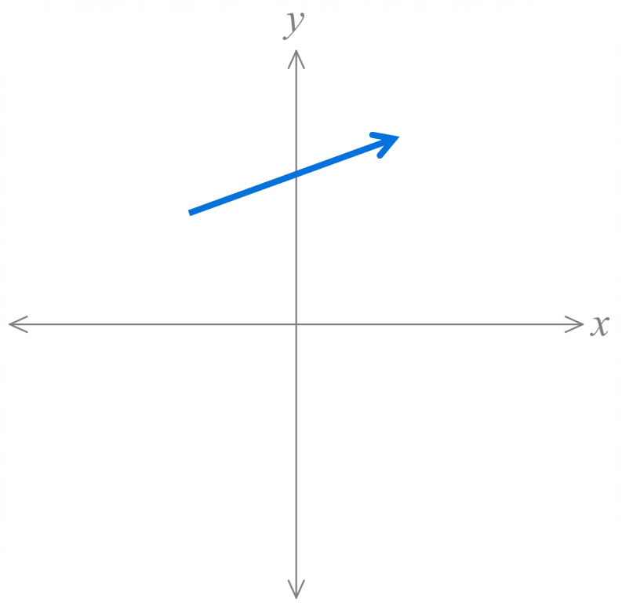 | 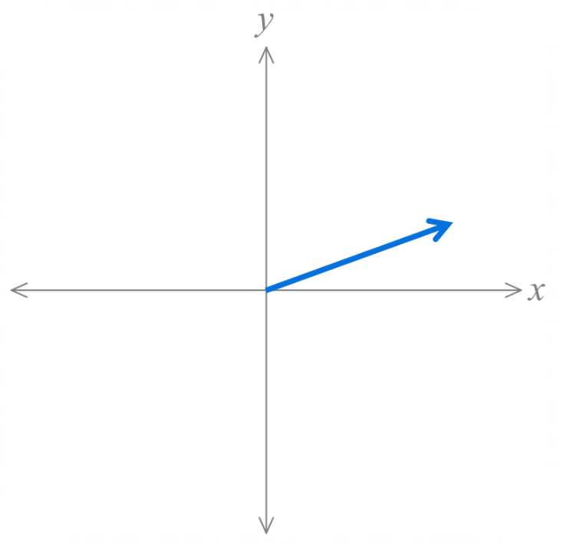 | 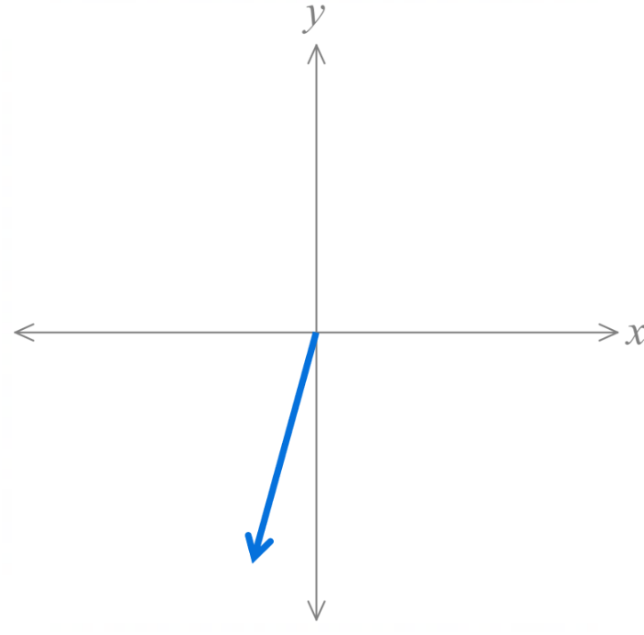
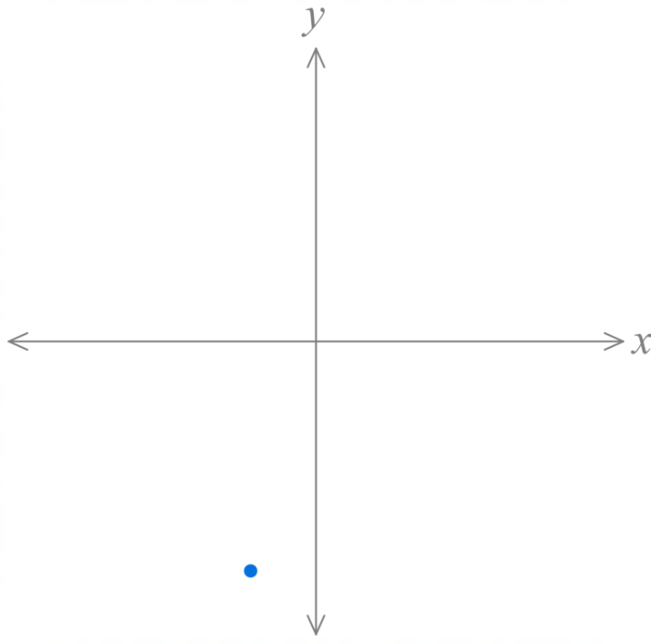 | 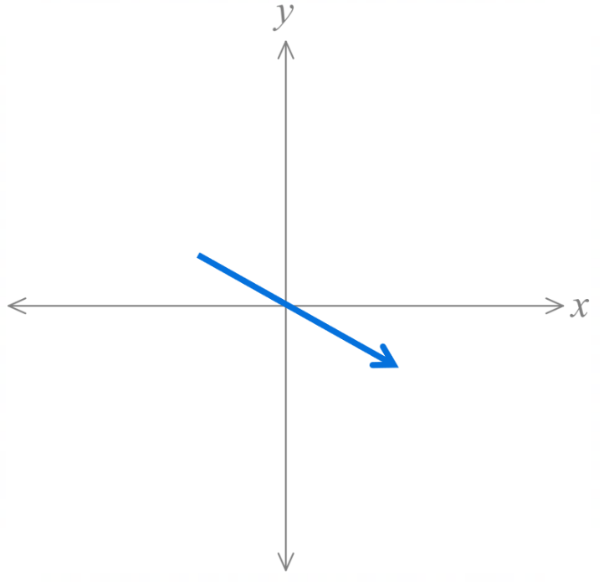 | 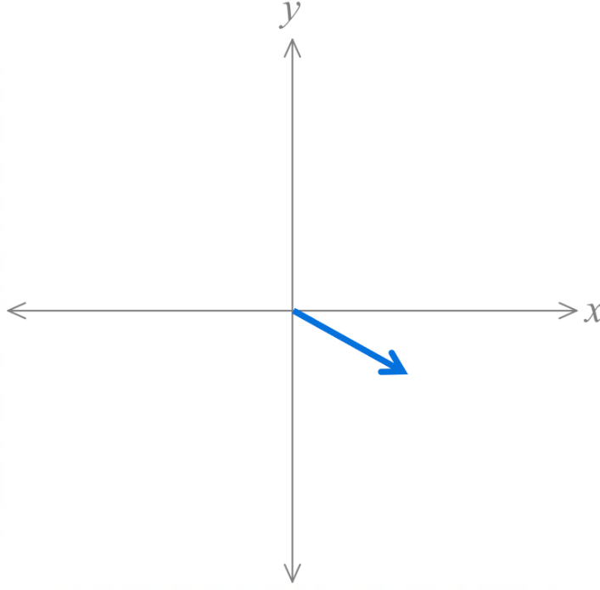
- Position Vectors
$\vec{OP}$ is the position vector with tail at the origin and tip at a point $P\left(x,y\right).$
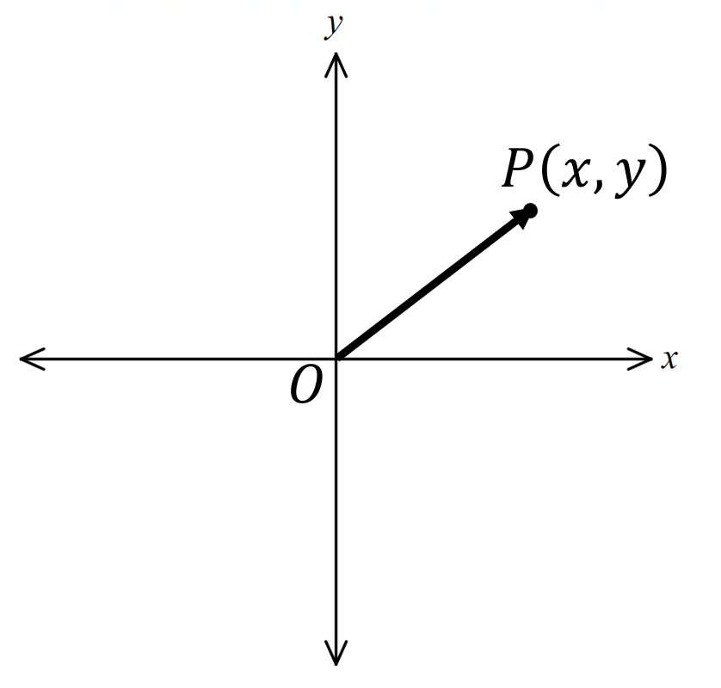

$\vec{OP}=xi+yj=\left(\begin{aligned}x \\ y\end{aligned}\right)$

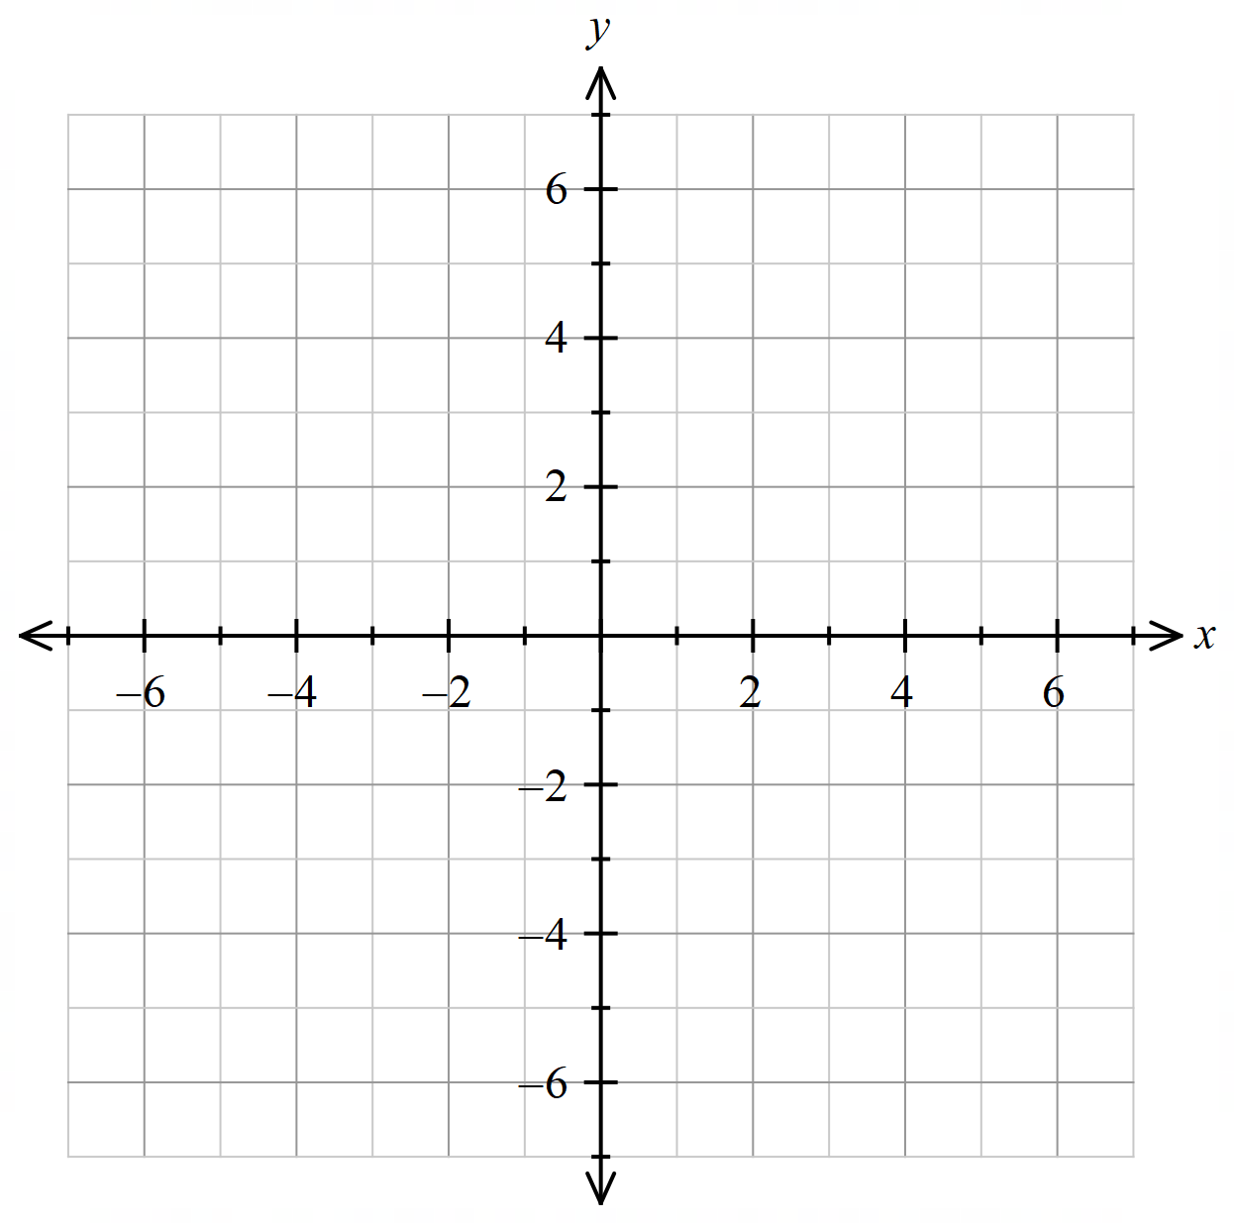

- Interpret position vectors
Sketch these position vectors.
- $\vec{OP}=5i+7j$
- $\vec{OQ}=\left(\begin{aligned}6 \\ 2\end{aligned}\right)$
- $\vec{OR}=-3i+4j$
- $\vec{OS}=-5j$

Write these position vectors in column and component notation.
- $\vec{OA}=$  - $\vec{OB}=$  - $\vec{OC}=$  - $\vec{OD}=$  - $\vec{OE}=$ | 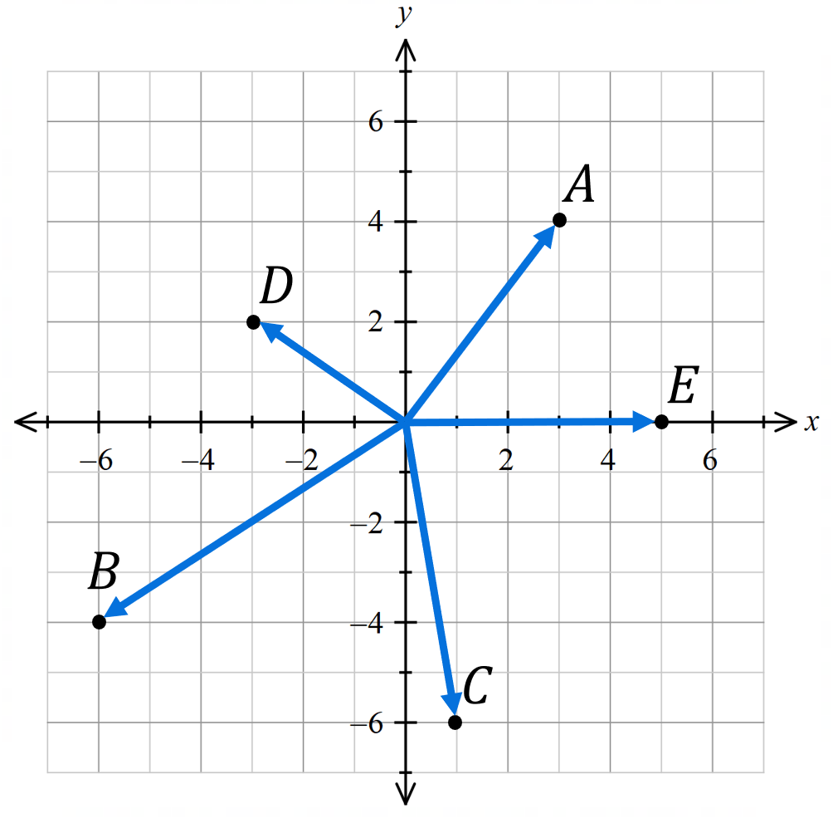

- Investigation Point-to-point to position form.
We can express any vector using position vectors from the origin using the formula:
$$\vec{PQ}=\vec{OQ}-\vec{OP}$$
This law is a special application of the parallelogram law of subtraction: $\vec{AB}-\vec{AD}=\vec{DB}$
This formula makes vector calculations easier because we can work with component form.
Consider the following diagram:
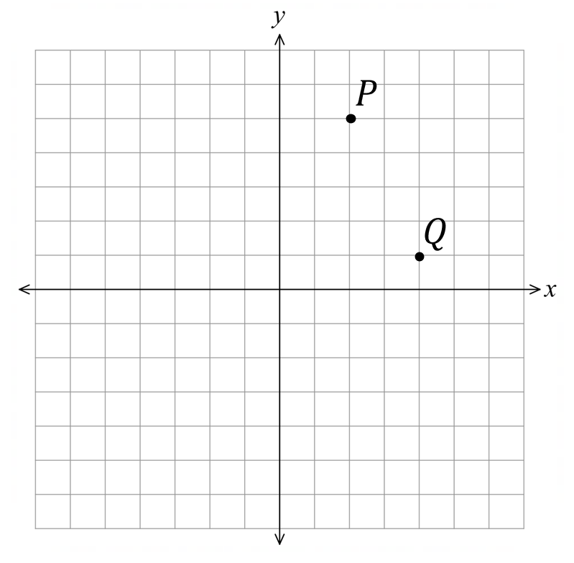
$\vec{OP}=\left(\begin{aligned}2 \\ 5\end{aligned}\right)$

$\vec{OQ}=$

$\vec{PQ}=$

$\vec{OQ}-\vec{OP}=$

Confirm $\vec{PQ}=\vec{OQ}-\vec{OP}$ geometrically.

Let $A\left(3,-1\right)$ and $B\left(-5,3\right)$.
Find $\vec{AB}$ using $\vec{AB}=\vec{OB}-\vec{OA}.$

Given $P\left(5,2\right)$ and $Q\left(6,-8\right)$, find $\vec{PQ}$ and $\vec{QP}$ using the formula.

$\vec{DE}=\left(\begin{aligned}3 \\ -4\end{aligned}\right).$ Find the coordinates of $E$ if $D$ is $\left(-2,-3\right)$

- Vector to Position Vector Formula
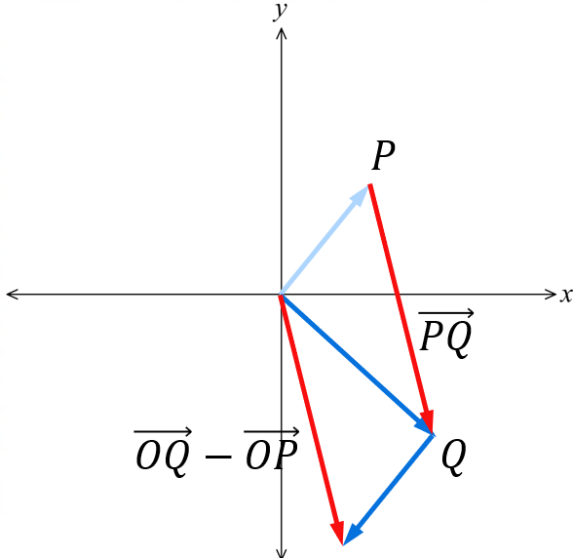
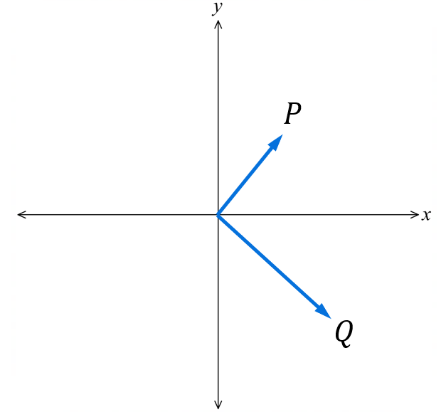
For $P\left(x,y\right)$ and $Q\left(u,v\right):$
$\vec{PQ}=\vec{OQ}-\vec{OP}$
$\vec{PQ}=\left(\begin{matrix}u-x \\ v-y\end{matrix}\right)$
Also:

$$\vec{PQ}=\vec{PO}+\vec{OQ}$$

- Always check your work with a sketch.

- Example Apply the formula $\vec{PQ}=\vec{OQ}-\vec{OP}$
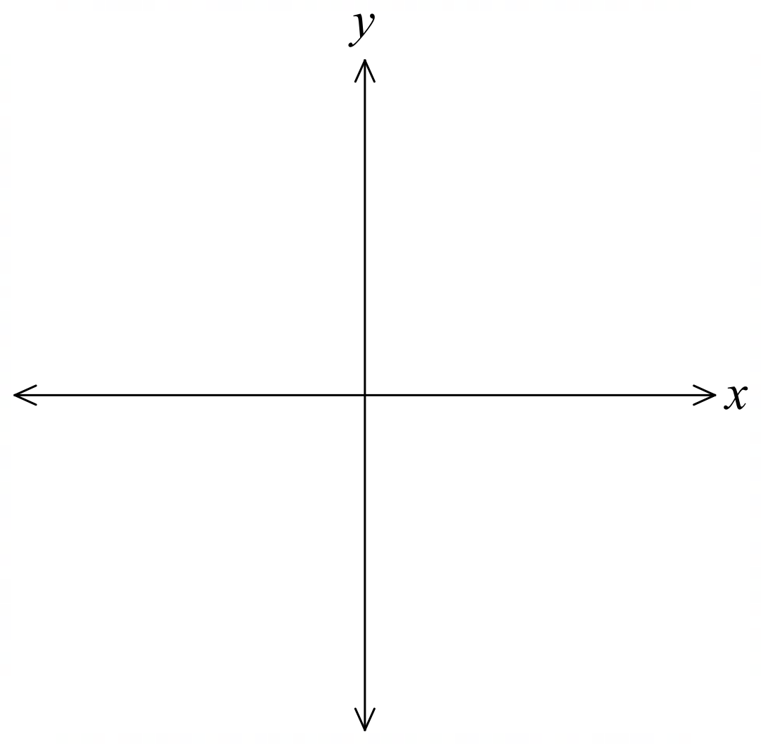
Given $A\left(-4,5\right)$ and $B\left(3,-1\right)$, find the magnitude and direction of $\vec{BA},$
giving your answer in exact form for magnitude and as an angle of inclination to 1 d.p.
$$\vec{BA}=\vec{OA}-\vec{OB}$$
$$=\left(\begin{aligned}-4 \\ 5\end{aligned}\right)-\left(\begin{aligned}3 \\ -1\end{aligned}\right)$$
$$=\left(\begin{aligned}-7 \\ 6\end{aligned}\right)$$
$$\left|\vec{BA}\right|=\sqrt{{\left(-7\right)}^{2}+6^{2}}=\sqrt{85}$$
$$A=\tan^{-1}\left(\frac{6}{7}\right)=40.6°$$
$$θ=180-40.6°=139.4°$$

Check your answer using a sketch.

- Guided Practice
Given $\vec{OD}=-8i+2j$ and $\vec{OE}=-5j$, find the magnitude and direction of $\vec{DE}$,
giving your answer in exact form for magnitude and as an angle of inclination to 1 d.p.

$\sqrt{113}$ and $θ=318.8°$

Foundation
- Write each vector $\vec{AB}$ using vector notation and draw the equivalent position vector.
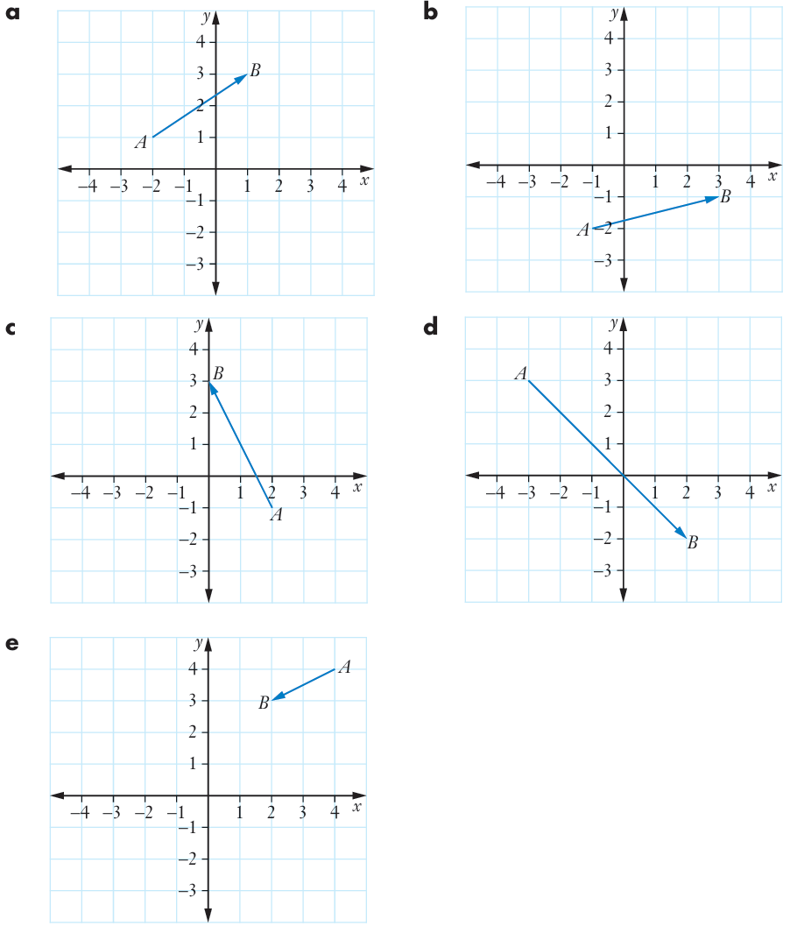  $$\left(\begin{aligned}3 \\ 2\end{aligned}\right)$$ | $$\left(\begin{aligned}4 \\ 1\end{aligned}\right)$$ | $$\left(\begin{aligned}-2 \\ 4\end{aligned}\right)$$
$$\left(\begin{aligned}5 \\ -5\end{aligned}\right)$$ | $$\left(\begin{aligned}-2 \\ -1\end{aligned}\right)$$

- On the diagram, show position vectors representing:
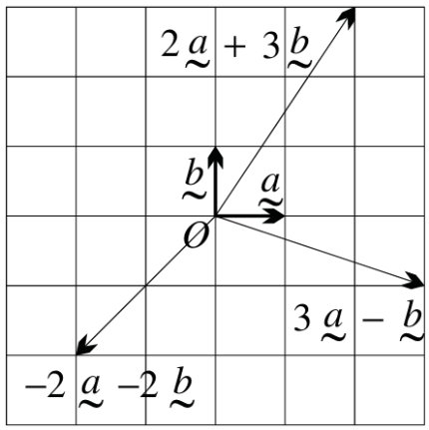
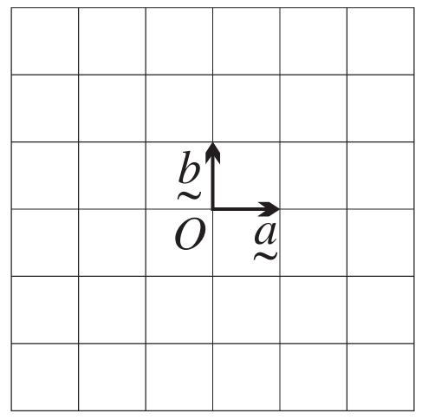
  - $2\overset{̰}{a} + 3\overset{̰}{b}$

  - $3\overset{̰}{a} - \overset{̰}{b}$

  - $-2\overset{̰}{a} - 2\overset{̰}{b}$

- Given $\vec{OA} = \left(\begin{aligned}-3 \\ 4\end{aligned}\right)$ and $\vec{OB} = \left(\begin{aligned}2 \\ 1\end{aligned}\right),$ find the resultant vector for:
- $\vec{OA} + \vec{OB}$  $$\left(\begin{aligned}-1 \\ 5\end{aligned}\right)$$ | - $\vec{OB} - \vec{OA}$  $$\left(\begin{aligned}5 \\ -3\end{aligned}\right)$$ | - $\vec{OA} - \vec{OB}$  $$\left(\begin{aligned}-5 \\ 3\end{aligned}\right)$$

Development
- If $\vec{OX} = \left(\begin{aligned}2 \\ 5\end{aligned}\right)$ and $\vec{OY} = \left(\begin{aligned}-4 \\ 3\end{aligned}\right),$ find the resultant vector for:
- $\vec{OX} + \vec{OY}$  $$\left(\begin{aligned}-2 \\ 8\end{aligned}\right)$$ | - $\vec{OY} - \vec{OX}$  $$\left(\begin{aligned}-6 \\ -2\end{aligned}\right)$$

- Given $\vec{OA} = \left(\begin{aligned}5 \\ 2\end{aligned}\right)$ and $\vec{OB} = \left(\begin{aligned}1 \\ 1\end{aligned}\right)$, find the magnitude and direction of:
Draw a sketch to check your answer.
- $\vec{AB}$  $$4.1, 194°$$ | - $\vec{BA}$  $$4.1, 14°$$ | - $\vec{OA} + \vec{OB}$  $$6.7, 27°$$

- Given $\vec{OX} = \left(\begin{aligned}-2 \\ 1\end{aligned}\right)$ and $\vec{OY} = \left(\begin{aligned}8 \\ -3\end{aligned}\right),$ find the magnitude and direction of:
Draw a sketch to check your answer.
- $\vec{XY}$  $$10.8, 338°$$ | - $\vec{OX} + \vec{OY}$  $$6.3, 342°$$ | - $\vec{OX} - \vec{OY}$  $$10.8, 158°$$

- Given $\vec{OA} = \left(\begin{aligned}a \\ b\end{aligned}\right)$ and $\vec{OB} = \left(\begin{aligned}-1 \\ -3\end{aligned}\right),$ the vector for $\vec{AB}$ is $\left(\begin{aligned}7 \\ 3\end{aligned}\right).$
Find the values of $a$ and $b$.

$$a = -8, b = -6$$
- Suppose that $P$ is the point (4, -1), $Q$ is the point (-3, 5) and $O$ is the origin.
Write as column vectors:
  - $\vec{OP}$
$$\vec{OP} = \left(\begin{aligned}4 \\ -1\end{aligned}\right)$$
  - $2\vec{OP} - \vec{OQ}$
$$2\vec{\left(OP\right)} = \left(\begin{aligned}8 \\ -2\end{aligned}\right) \\ \vec{\left(OQ\right)} = \left(\begin{aligned}-3 \\ 5\end{aligned}\right) \\ 2\vec{OP} - \vec{OQ} = \left(\begin{aligned}8 - \left(-3\right) \\ -2 - 5\end{aligned}\right)= \left(\begin{aligned}11 \\ -7\end{aligned}\right)$$
  - $\vec{PQ}$
$$\vec{PQ} = \vec{OQ} - \vec{OP} \\ = \left(\begin{aligned}-3 - 4 \\ 5 - \left(-1\right)\end{aligned}\right) \\ = \left(\begin{aligned}-7 \\ 6\end{aligned}\right)$$
  - $\vec{QP}$
$$\vec{QP} = \vec{OP} - \vec{OQ} \\ = \left(\begin{aligned}4 - \left(-3\right) \\ \left(-1\right)- 5\end{aligned}\right) \\ = \left(\begin{aligned}7 \\ -6\end{aligned}\right)$$

- If A and B are the points (1, -1) and (7, 3) respectively, find:
  - $\vec{AB}$ in component form,
$$\underset{∼}{a}= \vec{OA} = i - j \\ \underset{∼}{b}= \vec{OB} = 7i + 3j \\ \vec{AB} = \vec{OB} - \vec{OA} \\ = (7i + 3j) - \left(i - j\right) \\ = 6i + 4j$$
  - $|\vec{AB}|,$
$$\left|\vec{AB}\right|= \sqrt{6^{2}+ 4^{2}} \\ = 2√13$$
  - the unit vector in the direction of $\vec{AB}$.
$$\hat{AB} =\frac{\vec{AB}}{\left|\vec{AB}\right|} \\ =\frac{6i + 4j}{2\sqrt{13}} \\ =\frac{3}{\sqrt{13}}i +\frac{2}{\sqrt{13}}j$$

- Given three points A, B, and C with position vectors $\left(\begin{aligned}2 \\ 3\end{aligned}\right), \left(\begin{aligned}5 \\ 7\end{aligned}\right),$ and $\left(\begin{aligned}8 \\ k\end{aligned}\right)$ respectively, find the value of $k$ such that $\vec{AB}$ is parallel to $\vec{BC}$.

$$\vec{AB} = \left(\begin{aligned}5 \\ 7\end{aligned}\right)- \left(\begin{aligned}2 \\ 3\end{aligned}\right)= \left(\begin{aligned}3 \\ 4\end{aligned}\right) \\ \vec{BC} = \left(\begin{aligned}8 \\ k\end{aligned}\right)- \left(\begin{aligned}5 \\ 7\end{aligned}\right)= \left(\begin{aligned}3 \\ k-7\end{aligned}\right) \\ For parallel: k-7 = 4, \\ k = 11$$

Solving Geometric Problems with Vectors

- Vector Laws
The following laws are useful for solving geometrical problems:
Commutative Law  $$\overset{̰}{a}+\overset{̰}{b}=\overset{̰}{b}+\overset{̰}{a}$$ | Negative Vector Law  $$\vec{AB}=-\vec{BA}$$
Triangle Law of Addition  $$\vec{AB}+\vec{BC}=\vec{AC}$$ | Parallelogram Law of Subtraction  $$\vec{AB}-\vec{AD}=\vec{DB}$$
Vector to Position Vector Formula
$\vec{PQ}=\vec{OQ}-\vec{OP}$, where $O$ is the origin

- Example Solve geometric problems involving vectors.
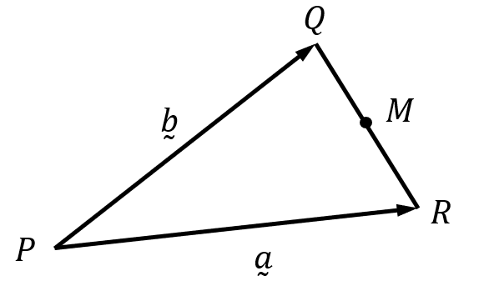
PQR is a triangle. $M$ is the midpoint of $QR$.
Let $\vec{PR}=\overset{̰}{a}$ and $\vec{PQ}=\overset{̰}{b}$.

Find in terms of $\overset{̰}{a}$ and $\overset{̰}{b}$:
- $\vec{QR}$  $\vec{QR}=\vec{PR}-\vec{PQ}$ (▱ law)  $=\overset{̰}{a}-\overset{̰}{b}$ | - $\vec{QM}$  $\vec{QM}=\frac{1}{2}\vec{QR}$  $=\frac{1}{2}\left(\overset{̰}{a}-\overset{̰}{b}\right)$ | - $\vec{PM}$  $\vec{PM}=\vec{PQ}+\vec{QM}$ (△ law)  $$=\overset{̰}{b}+\frac{1}{2}\left(\overset{̰}{a}-\overset{̰}{b}\right)$$  $$=\frac{1}{2}\overset{̰}{a}+\frac{1}{2}\overset{̰}{b}$$

- Guided Practice
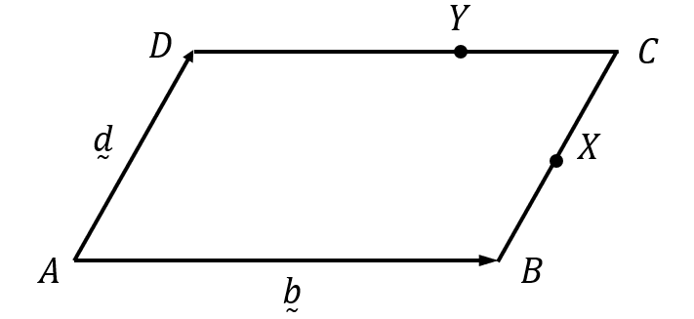
ABCD is a parallelogram. $X$ is the midpoint of $BC$ and the lengths $DY:YC$ are in the ratio 2:1.
Let $\vec{AD}=\overset{̰}{d}$ and $\vec{AB}=\overset{̰}{b}.$
Show that $\vec{XY}=\frac{1}{2}\left(\overset{̰}{d}-\frac{2}{3}\overset{̰}{b}\right)$

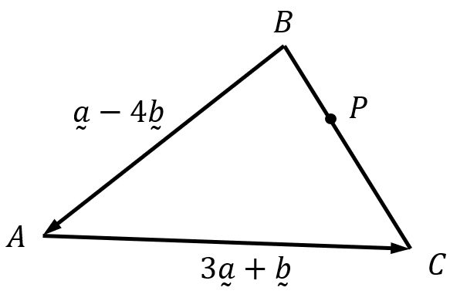
ABC is a triangle. The point $P$ lies on line $BC$ such that $BP:PC=1:2$.
It is given that $\vec{BA}=\overset{̰}{a}-4\overset{̰}{b} and \vec{AC}=3\overset{̰}{a}+\overset{̰}{b}.$

Find in terms of $\overset{̰}{a}$ and $\overset{̰}{b}$:
- $\vec{BC}$  $$4\overset{̰}{a}-3\overset{̰}{b}$$ | - $\vec{BP}$  $$\frac{4}{3}\overset{̰}{a}-\overset{̰}{b}$$ | - $\vec{AP}$  $$\frac{1}{3}\overset{̰}{a}+3\overset{̰}{b}$$
- Parallel Vectors
Two vectors $\overset{̰}{a}$ and $\overset{̰}{b}$ are parallel if they have the same direction or opposite directions.
In other words, one vector is a scalar multiple of the other.
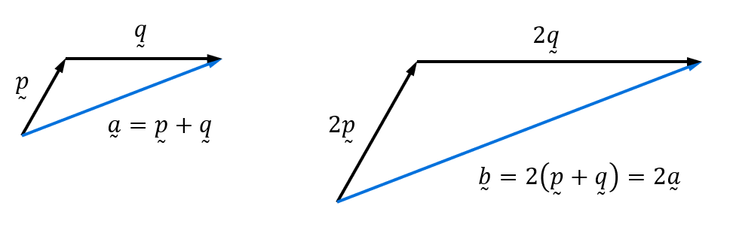
$$\overset{̰}{b}=λ\overset{̰}{a}, λ∈R$$

- Example Solve geometric problems involving vectors.
$\vec{AB}=\overset{̰}{a}+2\overset{̰}{b}$ and $\vec{BC}=\overset{̰}{a}-4\overset{̰}{b}$.
Show that $\vec{AC}$ is parallel to $\overset{̰}{a}-\overset{̰}{b}$.
$\vec{AC}=\vec{AB}+\vec{BC}$ (△ law)
$=\left(\overset{̰}{a}+2\overset{̰}{b}\right)+\left(\overset{̰}{a}-4\overset{̰}{b}\right)$
$=2\overset{̰}{a}-2\overset{̰}{b}$
$=2\left(a-\overset{̰}{b}\right)$ $∴$ parallel to $\overset{̰}{a}-\overset{̰}{b}$

- Guided Practice
$\vec{AB}=2\overset{̰}{a}+\overset{̰}{b}$ and $\vec{BC}=2\overset{̰}{a}-3\overset{̰}{b}$.
Show that $\vec{AC}$ is parallel to $2\overset{̰}{a}-\overset{̰}{b}$.

$\vec{PQ}=6\overset{̰}{a}+\overset{̰}{b}$ and $\vec{RQ}=2\overset{̰}{a}+5\overset{̰}{b}$.
Show that $\vec{PR}$ is parallel to $\overset{̰}{b}-\overset{̰}{a}$.

- Collinear
Three (or more) points are collinear if they all lie on the same straight line.
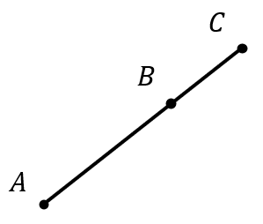
Three points A, B, C are collinear if the vectors connecting them are parallel and share a common point.
- The vectors $\vec{AB}$ and $\vec{BC}$ are parallel
- (or vectors $\vec{AB}$ and $\vec{AC}$ are parallel).

- Example Solve geometric problems involving vectors.
$\vec{AC}=4\overset{̰}{a}-8\overset{̰}{b}$ and $\vec{BC}=6\overset{̰}{a}-12\overset{̰}{b}$.
Prove that points $A,B,C$ are collinear.
$\vec{AC}=4\overset{̰}{a}-8\overset{̰}{b}$ $\vec{BC}=6\overset{̰}{a}-12\overset{̰}{b}$
$=4\left(\overset{̰}{a}-2\overset{̰}{b}\right)$ $=6\left(\overset{̰}{a}-2\overset{̰}{b}\right)$

$\vec{AC}$ and $\vec{BC}$ are parallel and pass through common point $C$, $∴$ parallel.

- Guided Practice
$\vec{PQ}=3\overset{̰}{p}+9\overset{̰}{q}$ and $\vec{PR}=5\overset{̰}{p}+15\overset{̰}{q}$.
Prove that points $P,Q,R$ are collinear.

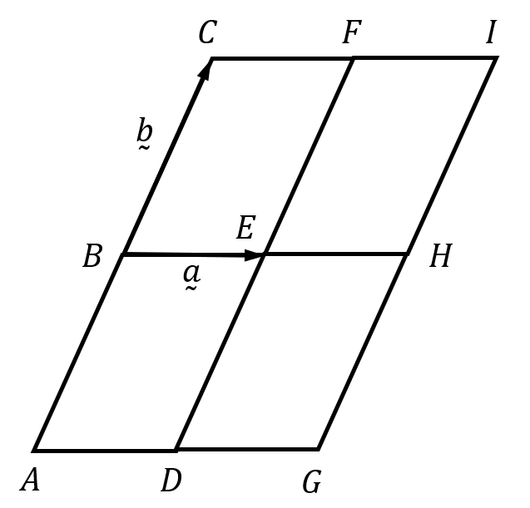
The diagram shows congruent parallelograms.
Let $\vec{BE}=\overset{̰}{a}$ and $\vec{BC}=\overset{̰}{b}$.
Prove that $A,E,I$ lie on a straight line.

Foundation
- Let $\underset{∼}{a},\underset{∼}{b}$ and $\underset{∼}{m}$ be the respective position vectors representing the points $A(4, -7), B(6, 3)$ and $M$, where $M$ is the midpoint of $AB$. Write in component form:
  - $\underset{∼}{a}$
$$4i-7j$$
  - $\underset{∼}{b}$
$$6i+3j$$
  - $\underset{∼}{m}$
$$M=\left(\frac{4+6}{2},\frac{-7+3}{2}\right) \\ =(5,-2) \\ =5i-2j$$

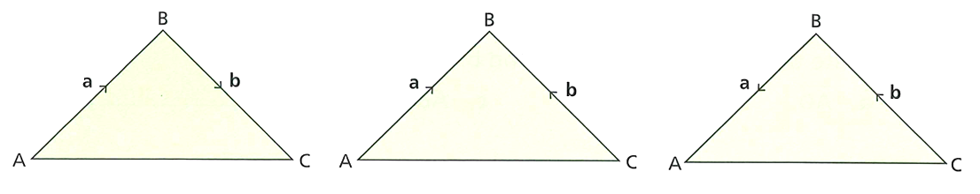
- Write the vectors $\vec{AC}$ in terms of $\underset{∼}{a}$ and $\underset{∼}{b}$.
$$\underset{∼}{a}+\underset{∼}{b}$$ | $$\underset{∼}{a}-\underset{∼}{b}$$ | $$-\underset{∼}{a}-\underset{∼}{b}$$

- PQR is a triangle. $\vec{PR} =2\underset{∼}{a}$ and$\vec{RQ} =\underset{∼}{b}$.
Write in terms of $\underset{∼}{a}$ and $\underset{∼}{b}:$
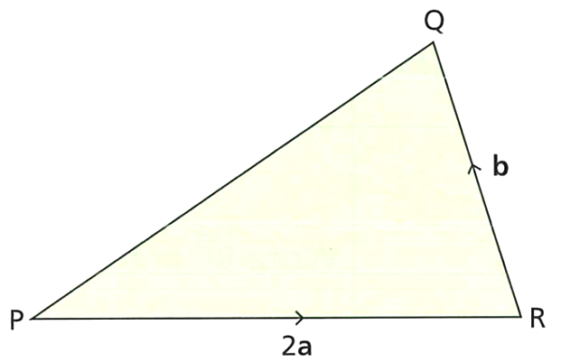
  - $\vec{PQ}$

$\underset{∼}{2a}+\underset{∼}{b}$
  - $\vec{QP}$

$$-\underset{∼}{2a}-\underset{∼}{b}$$
- ABC is a triangle. $\vec{AB}=2\underset{∼}{a}+\underset{∼}{b}$ and $\vec{BC} =\underset{∼}{a} -3\underset{∼}{b}.$
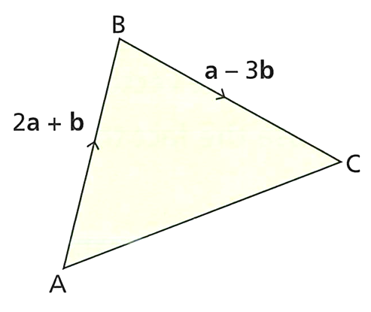
Write in terms of $\underset{∼}{a}$ and $\underset{∼}{b}$:
  - $\vec{AC}$

$\underset{∼}{3a}-\underset{∼}{2b}$
  - $\vec{CA}$

$$-\underset{∼}{3a}+\underset{∼}{2b}$$
- LMN is a triangle. $\vec{ML} =3\underset{∼}{a}$ and $\vec{NL} =\underset{∼}{a}+\underset{∼}{b}.$
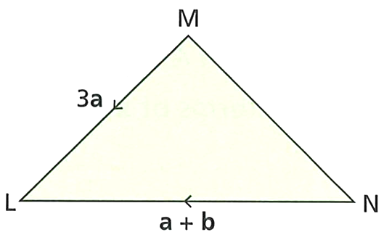
Write in terms of $\underset{∼}{a}$ and $\underset{∼}{b}:$
  - $\vec{LM}$
$$-3\underset{∼}{a}$$
  - $\vec{NM}$
$$-2\underset{∼}{a}+\underset{∼}{b}$$

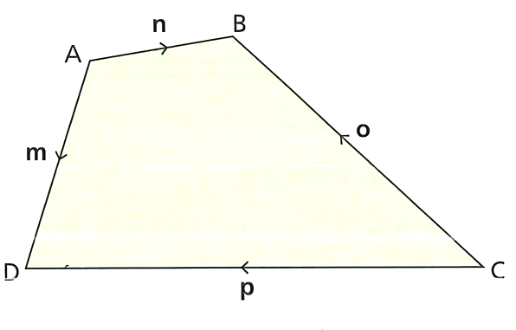
- Here is the quadrilateral ABCD.
  - Write the vector $\vec{AC}$ in terms of $\underset{∼}{n}$ and $\underset{∼}{o}$.

$\underset{∼}{n}-\underset{∼}{o}$
  - Write the vector $\vec{AC}$ in terms of $\underset{∼}{m}$ and $\underset{∼}{p}$.

$\underset{∼}{m}-\underset{∼}{p}$
  - Complete these vector journeys for $\vec{DB}$.
    - $\vec{DB} = \vec{DA} + \vec{AB} =$ ……………
$$-\underset{∼}{m}+\underset{∼}{n}$$
    - $\vec{DB} = \vec{DC} + \vec{CB} =$……………
$$-\underset{∼}{p}+\underset{∼}{o}$$
- $WXYZ$ is a quadrilateral.
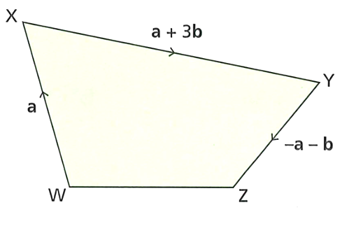
Write the vector $\vec{WZ}$in terms of $\underset{∼}{a}$ and $\underset{∼}{b}$.

$$\underset{∼}{a}+\underset{∼}{2b}$$

- $ABC$ is a triangle. The point $M$ is the midpoint of $BC$.
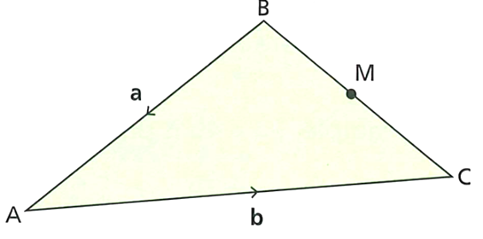
Write the vectors in terms of $\underset{∼}{a}$ and $\underset{∼}{b}$.
  - $\vec{BC}$
$$\underset{∼}{a}+\underset{∼}{b}$$
  - $\vec{BM}$
$$\left(\frac{1}{2}\right)\underset{∼}{a}+\left(\frac{1}{2}\right)\underset{∼}{b}$$
  - $\vec{AM}$
$$-\left(\frac{1}{2}\right)\underset{∼}{a}+\left(\frac{1}{2}\right)\underset{∼}{b}$$
- $PQR$ is a triangle. The point $M$ is the midpoint of $QR$.
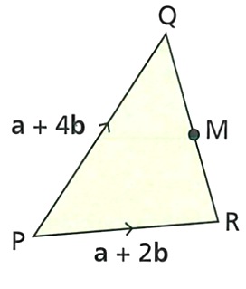
  - Write $\vec{QM}$ in terms of $\underset{∼}{a}$ and $\underset{∼}{b}$.
$$-\underset{∼}{b}$$
  - Write $\vec{PM}$ in terms of $\underset{∼}{a}$ and $\underset{∼}{b}$.
$$\underset{∼}{a}+\underset{∼}{3b}$$

- $ABC$ is a triangle. The point $M$ is the midpoint of $BA$.
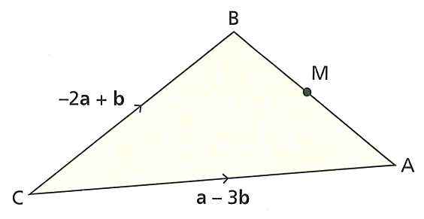
  - Write $\vec{BM}$ in terms of $\underset{∼}{a}$ and $\underset{∼}{b}$.
$$\frac{3}{2}\underset{∼}{a}-\underset{∼}{2b}$$
  - Write $\vec{CM}$ in terms of $\underset{∼}{a}$ and $\underset{∼}{b}.$
$$-\frac{1}{2}\underset{∼}{a}-\underset{∼}{b}$$

- $ABCD$ is a trapezium. $\vec{AD} = 3\vec{BC}$.
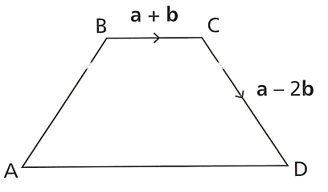
Write the vectors in terms of $\underset{∼}{a}$ and $\underset{∼}{b}.$
  - $\vec{AD}$
$$3\underset{∼}{a} +3\underset{∼}{b}$$
  - $\vec{AC}$
$$2\underset{∼}{a}+5\underset{∼}{b}$$
  - $\vec{AB}$
$$\underset{∼}{a}+4\underset{∼}{b}$$
- $\vec{OA} =\underset{∼}{x},$ $\vec{OB} =\underset{∼}{y}.$
$N$ is the point on $AB$ such that $AN : NB = 1 : 3$.
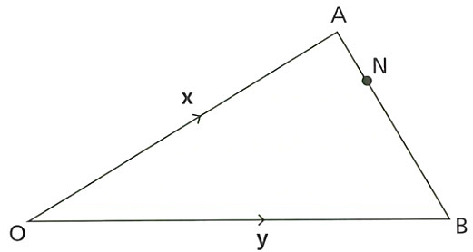
Write $\vec{ON}$ in terms of $\underset{∼}{x}$ and $\underset{∼}{y}.$

$$\frac{3}{4}\underset{∼}{x}+\frac{1}{4}\underset{∼}{y}$$

Development
- $\vec{AB} =4\underset{∼}{a}+6\underset{∼}{b}$ and $\vec{CD} = 10\underset{∼}{a} + 15\underset{∼}{b}.$
Show that $\vec{AB}$ and $\vec{CD}$ are parallel.

$$4\underset{∼}{a} + 6\underset{∼}{b} = 2\left(2\underset{∼}{a} + 3\underset{∼}{b}\right)and \underset{∼}{10a} + 15\underset{∼}{b} = 5\left(2\underset{∼}{a} + 3\underset{∼}{b}\right)$$
Both vectors are scalar multiples of $\left(2\underset{∼}{a} + 3\underset{∼}{b}\right)$ so they are parallel.
- $\vec{PQ} =\underset{∼}{a} + 3\underset{∼}{b}$ and $\vec{RS} = 4\underset{∼}{a} + 15\underset{∼}{b}$.
Show that $\vec{PQ}$ and $\vec{RS}$ are not parallel.

$$4\left(\underset{∼}{a}+\underset{∼}{3b}\right)=4\underset{∼}{a}+12\underset{∼}{b} \\ ≠4\underset{∼}{a}+15\underset{∼}{b}$$
- The triangle $ABC$ has vertices $A\left(2\sqrt{3}, 3\right), B\left(3\sqrt{3}, 4\right)$and $C\left(2\sqrt{3}, 5\right)$.
  - Find $\vec{AB}$ and $\vec{CB}$ as column vectors.
$$\vec{\left(OA\right)} = \left(\begin{aligned}2\sqrt{3} \\ 3\end{aligned}\right) \\ \vec{OB} = \left(\begin{aligned}3\sqrt{3} \\ 4\end{aligned}\right) \\ \vec{OC} = \left(\begin{aligned}2\sqrt{3} \\ 5\end{aligned}\right) \\ \vec{AB} = \vec{OB} - \vec{OA} = \left(\begin{aligned}3\sqrt{3}- 2\sqrt{3} \\ 4 - 3\end{aligned}\right)= \left(\begin{aligned}\sqrt{3} \\ 1\end{aligned}\right) \\ \vec{\left(CB\right)} = \vec{\left(OB\right)} - \vec{\left(OC\right)} = \left(\begin{aligned}3\sqrt{3}- 2\sqrt{3} \\ 4 - 5\end{aligned}\right)= \left(\begin{aligned}\sqrt{3} \\ -1\end{aligned}\right)$$

  - Hence find $\left|\vec{AB}\right|$ and $\left|\vec{CB}\right|$.
$$|\vec{AB}| = \sqrt{{\left(\sqrt{3}\right)}^{2}+ 1^{2}} \\ = 2 \\ |\vec{CB}| = \sqrt{{\left(\sqrt{3}\right)}^{2}+ {\left(-1\right)}^{2}} \\ = 2$$

  - What type of special triangle is ABC? Why?
$$\vec{\left(AC\right)} = \vec{\left(OC\right)} - \vec{\left(OA\right)} = \left(\begin{aligned}2\sqrt{3}- 2\sqrt{3} \\ 5 - 3\end{aligned}\right)= \left(\begin{aligned}0 \\ 2\end{aligned}\right) \\ |\vec{AC}| = \sqrt{0^{2}+ 2^{2}} \\ = 2 \\ |\vec{AB}| = |\vec{CB}| = |\vec{AC}| \\ Hence, ABC is an equilateral triangle as each side has a length of 2.$$

- The quadrilateral $ABCD$ has vertices$A(-7, -5), B(8, -2), C(10, 9)$ and $D(-5, 6).$
Show that $\vec{AD} = \vec{BC}$, and hence explain why $ABCD$ is a parallelogram.
$$\vec{AD} = \vec{OD} - \vec{OA} = \left(\begin{aligned}-5 - \left(-7\right) \\ 6 - \left(-5\right)\end{aligned}\right)= \left(\begin{aligned}2 \\ 11\end{aligned}\right) \\ \vec{BC} = \vec{OC} - \vec{OB} = \left(\begin{aligned}10 - 8 \\ 9 - \left(-2\right)\end{aligned}\right)= \left(\begin{aligned}2 \\ 11\end{aligned}\right) \\ Hence, \vec{AD} = \vec{BC}. \\ Therefore, ABCD is a parallelogram as opposite sides are equal and parallel.$$

- The quadrilateral PQRS has vertices $P(-3, -4), Q(2, -2), R(4, 3)$ and $S(-1, 1)$.
  - Show that $\vec{PQ} = \vec{SR}$.
$$\vec{PQ} = \vec{OQ} - \vec{OP} = \left(\begin{aligned}2 - \left(-3\right) \\ -2 - \left(-4\right)\end{aligned}\right)= \left(\begin{aligned}5 \\ 2\end{aligned}\right) \\ \vec{SR} = \vec{OR} - \vec{OS} = \left(\begin{aligned}4 - \left(-1\right) \\ 3 - 1\end{aligned}\right)= \left(\begin{aligned}5 \\ 2\end{aligned}\right) \\ Hence, \vec{\left(PQ\right)} = \vec{\left(SR\right)}$$
  - Show that $|\vec{PQ}| = |\vec{QR}|.$
$$|\vec{PQ}| = \sqrt{5^{2}+ 2^{2}} \\ = \sqrt{29} \\ \vec{QR} = \vec{OR} - \vec{OQ} = \left(\begin{aligned}4 - 2 \\ 3 - \left(-2\right)\end{aligned}\right)= \left(\begin{aligned}2 \\ 5\end{aligned}\right) \\ \left|\vec{QR}\right|= \sqrt{2^{2}+ 5^{2}} \\ = \sqrt{29} \\ Hence, |\vec{PQ}| = |\vec{QR}|.$$

  - What type of special quadrilateral is $PQRS$? Give reasons for your answer.

PQRS is a rhombus as opposite sides are parallel and adjacent sides are equal in length.
- The parallelogram $WXYZ$ has vertices $W(-6, 4), X(6, 2), Y(4, 9)$and $Z(a, b).$
Use vectors to find the values of $a$ and $b$.
$$\vec{WZ} = \vec{OZ} - \vec{OW} = \left(\begin{aligned}a - \left(-6\right) \\ b - 4\end{aligned}\right)= \left(\begin{aligned}a + 6 \\ b - 4\end{aligned}\right) \\ \vec{XY} = \vec{OY} - \vec{OX} = \left(\begin{aligned}4 - 6 \\ 9 - 2\end{aligned}\right)= \left(\begin{aligned}-2 \\ 7\end{aligned}\right) \\ As WXYZ is a parallelogram, opposite sides are equal hence, \\ \vec{WZ} = \vec{XY} \\ \left(\begin{aligned}a + 6 \\ b - 4\end{aligned}\right)= \left(\begin{aligned}-2 \\ 7\end{aligned}\right) \\ a + 6 = -2 \\ a = -8 \\ b - 4 = 7 \\ b = 11$$

- The quadrilateral $OABC$ has vertices $O(0, 0), A(5, -3), B(7, 4)$ and $C(2, 7).$
  - Show that $\vec{OA} +\frac{1}{2}\vec{AC} =\frac{1}{2}\vec{OB}$.
$$\vec{AC} = \vec{OC} - \vec{OA} = \left(\begin{aligned}2 - 5 \\ 7 - \left(-3\right)\end{aligned}\right)= \left(\begin{aligned}-3 \\ 10\end{aligned}\right) \\ \frac{1}{2}\vec{\left(AC\right)} = \left(\begin{aligned}-\frac{3}{2} \\ 5\end{aligned}\right) \\ \vec{OA} +\frac{1}{2}\vec{AC}= \left(\begin{aligned}5 \\ -3\end{aligned}\right)+ \left(\begin{aligned}-\frac{3}{2} \\ 5\end{aligned}\right) \\ = \left(\begin{aligned}\frac{7}{2} \\ 2\end{aligned}\right) \\ \vec{OB} = \left(\begin{aligned}7 \\ 4\end{aligned}\right) \\ \frac{1}{2}\vec{OB} = \left(\begin{aligned}\frac{7}{2} \\ 2\end{aligned}\right)$$
  - What type of special quadrilateral is $OABC$? Give a reason for your answer.
$\vec{OA} +\frac{1}{2}\vec{AC}$ is the vector from the origin to the midpoint of diagonal AC
$\frac{1}{2}\vec{OB}$ is the vector from the origin to the midpoint of diagonal OB
Since the midpoints of the diagonals are equal,
OABC is a parallelogram as diagonals bisect each other.

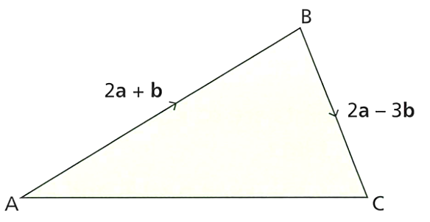
- ABC is a triangle.
  - Write $\vec{AC}$ in terms of $\underset{∼}{a}$ and $\underset{∼}{b}.$

$$4\underset{∼}{a}-2\underset{∼}{b}$$
  - Show that $\vec{AC}$ is parallel to $2\underset{∼}{a} -\underset{∼}{b}.$

$$4\underset{∼}{a}-2\underset{∼}{b}= 2\left(2\underset{∼}{a}-\underset{∼}{b}\right)$$
- PQR is a triangle.
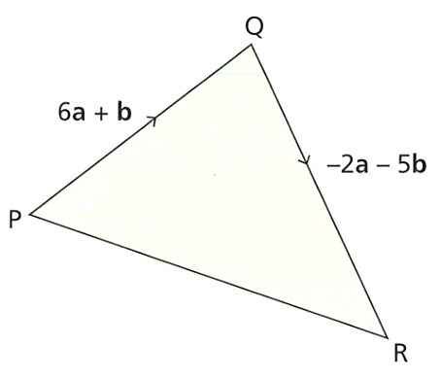
Show that $\vec{PR}$ is parallel to $\underset{∼}{a} -\underset{∼}{b}.$

$$\vec{PR}=\underset{∼}{4a}-\underset{∼}{4b}= 4\left(\underset{∼}{a}-\underset{∼}{b}\right)$$
- $OAB$ is a triangle. $M$ is the midpoint of $OA$. $N$ is the midpoint of $OB$.
$\vec{OM} =\underset{∼}{a}, \vec{ON} =\underset{∼}{b}.$
Show that $AB$ is parallel to $MN$.
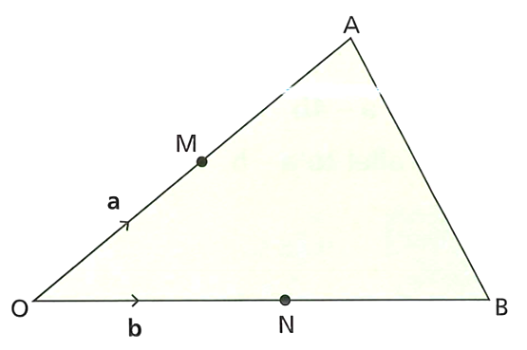

$\vec{AB} = -2\underset{∼}{a}+2\underset{∼}{b},$
$\vec{MN} = -\underset{∼}{a}+\underset{∼}{b},$
$\vec{AB} = -\underset{∼}{2a}+\underset{∼}{2b}= 2\left(-\underset{∼}{a}+\underset{∼}{b}\right)$

- $\vec{AC} = 2\underset{∼}{a} - 3\underset{∼}{b}$ and $\vec{BC} =8\underset{∼}{a} -12\underset{∼}{b}.$
Prove that the points A, B and C lie on a straight line.

$$\vec{BC}=8\underset{∼}{a}-12\underset{∼}{b}= 4\left(2\underset{∼}{a}-3\underset{∼}{b}\right).$$
$$\vec{BC} and \vec{AC} are parallel. C is a common point.$$
$$∴collinear$$

  - Test whether the points P, Q and R are collinear if
$$\vec{OP} = \left(\begin{aligned}-1 \\ 6\end{aligned}\right) and \vec{OQ} = \left(\begin{aligned}3 \\ 2\end{aligned}\right) and \vec{OR} = \left(\begin{aligned}8 \\ -3\end{aligned}\right).$$
$$\vec{PQ} = \vec{OQ} - \vec{OP} \\ = \left(\begin{aligned}3 - \left(-1\right) \\ 2 - 6\end{aligned}\right) \\ = \left(\begin{aligned}4 \\ -4\end{aligned}\right) \\ Gradient =\frac{y}{x}=\frac{-4}{4}= -1$$
$$\vec{QR} = \vec{OR} - \vec{OQ} \\ = \left(\begin{aligned}8 - 3 \\ \left(-3\right)- 2\end{aligned}\right) \\ = \left(\begin{aligned}5 \\ -5\end{aligned}\right) \\ Gradient =\frac{y}{x}=\frac{-5}{5}= -1 \\ P, Q and R are collinear as the gradient is -1.$$

  - Test whether the points A, B and C are collinear if
$$\vec{OA} = 3i + 8j and \vec{OB} = -i + 3j and \vec{OC} = -4i - j.$$
$$\vec{AB} = \vec{OB} - \vec{OA} \\ = \left(-i + 3j\right)- \left(3i + 8j\right) \\ = -4i - 5j \\ Gradient =\frac{y}{x}=\frac{-5}{-4}=\frac{5}{4}$$
$$\vec{BC} = \vec{OC} - \vec{OB} \\ = (-4i - j) - \left(-i + 3j\right) \\ = -3i - 4j \\ Gradient =\frac{y}{x}=\frac{-3}{-4}=\frac{3}{4} \\ A, B and C are not collinear as the gradient is not same.$$

- In △ABC, the point M is the midpoint of BC.
If $\vec{AC} = \overset{̰}{u}$ and $\vec{BC} = \overset{̰}{v}$, write in terms of $\overset{̰}{u}$ and $\overset{̰}{v}$:
  - $\vec{AB}$
$$\vec{AB}=\vec{AC}+\vec{CB} \\ =\vec{AC}-\vec{BC} \\ = \overset{̰}{u} - \overset{̰}{v}$$

  - $\vec{AM}$
$$\vec{AM}=\vec{AC}+\vec{CM} \\ =\vec{AC}-\vec{MC} \\ =\vec{AC}-\frac{1}{2}\vec{BC} \\ = \overset{̰}{u} -\frac{1}{2}\overset{̰}{v}$$

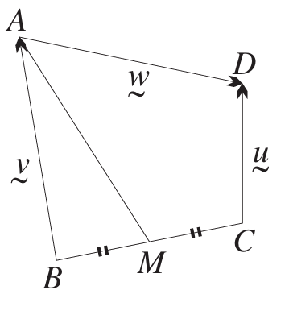
- In the diagram, ABCD is a quadrilateral and M is the midpoint of BC.
Let $\vec{CD} = \overset{̰}{u},$ $\vec{BA} = \overset{̰}{v}$ and $\vec{AD} = \overset{̰}{w}$.
  - Find $\vec{MB}$ in terms of $\overset{̰}{u}$, $\overset{̰}{v}$ and $\overset{̰}{w}$.

$$\vec{AC} = \vec{AD} + \vec{DC} \\ = \vec{AD} - \vec{CD} \\ = \overset{̰}{w} - \overset{̰}{u} \\ \vec{BC} = \vec{BA} + \vec{AC} = \overset{̰}{v}+ \overset{̰}{w}- \overset{̰}{u} \\ As M is the midpoint of BC, \\ \vec{BM} =\frac{1}{2}\vec{BC} =\frac{1}{2}\left(\overset{̰}{v}+ \overset{̰}{w}- \overset{̰}{u}\right) \\ \vec{MB} is in opposite direction of \vec{BM}. \\ Hence, \vec{MB} = -\frac{1}{2}\left(\overset{̰}{v}+ \overset{̰}{w}- \overset{̰}{u}\right) =\frac{1}{2}\left(\overset{̰}{u}- \overset{̰}{v}- \overset{̰}{w}\right)$$
  - Hence find $\vec{MA}$ in terms of $\overset{̰}{u}, \overset{̰}{v}$ and $\overset{̰}{w}$.
$$\vec{MA} = \vec{MB} + \vec{BA} \\ = \left(\frac{1}{2}\right)\left(\underset{∼}{u}-\underset{∼}{v}-\underset{∼}{w}\right)+\underset{∼}{v} \\ \vec{MA} =\frac{1}{2}\left(\overset{̰}{u}+ \overset{̰}{v}- \overset{̰}{w}\right)$$

- Suppose that P is a point on the line AB such that $\vec{AP} = k\vec{AB}$, where $k$ is a constant.
  - Show on a diagram the position of P relative to A and B if:
- $k >1$ | - $0< k < 1$ | 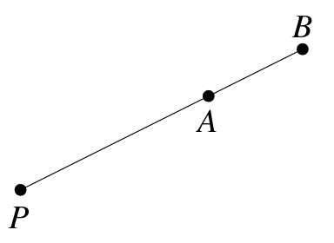  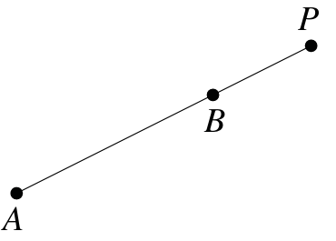  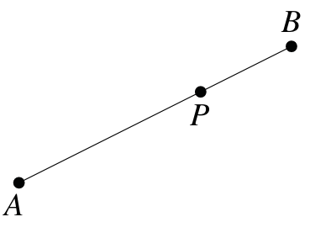  - $k< 0$

  - Find the value of $k$ for which:
- $\vec{AP} =\frac{3}{4}\vec{PB}$  $$\vec{AP} =\frac{3}{4}\left(\vec{AB} - \vec{AP}\right) \\ \vec{AP} =\frac{3}{4} \vec{AB} -\frac{3}{4}\vec{AP} \\ \frac{7}{4}\vec{AP} =\frac{3}{4}\vec{AB} \\ \frac{7}{4}k\vec{AB} =\frac{3}{4}\vec{AB} \\ k =\frac{3}{7}$$ | - $\vec{AP} = -\frac{3}{5}\vec{PB}$  $$\vec{AP} = -\frac{3}{5}\left(\vec{AB} - \vec{AP}\right) \\ \vec{AP} = -\frac{3}{5}\vec{AB} +\frac{3}{5}\vec{AP} \\ \frac{2}{5}\vec{AP} = -\frac{3}{5}\vec{AB} \\ \frac{2}{5}k\vec{AB} = -\frac{3}{5}\vec{AB} \\ k = -\frac{3}{2}$$ | - $\vec{AP} = -\frac{2}{3}\vec{PB}$  $$\vec{AP} = -\frac{2}{3}\vec{PB} \\ \vec{PB} = \vec{AB} - \vec{AP} \\ \vec{AP} = -\frac{2}{3}\left(\vec{AB} - \vec{AP}\right) \\ \vec{AP} = -\frac{2}{3}\vec{AB} +\frac{2}{3} \vec{AP} \\ \frac{1}{3}\vec{AP} = -\frac{2}{3} \vec{AB} \\ \frac{1}{3} k\vec{AB} = -\frac{2}{3}\vec{AB} \\ k = -2$$
  - Let $\overset{̰}{a}$, $\overset{̰}{b}$ and $\overset{̰}{p}$ be the respective position vectors of the points A, B and P relative to an origin O. Prove that $\overset{̰}{p}= \left(1 - k\right)\overset{̰}{a}+ k\overset{̰}{b}$.
$$\vec{AB} = \vec{OB} - \vec{OA} = \overset{̰}{b} - \overset{̰}{a} \\ and, \vec{AP} = \vec{OP} - \vec{OA} = \overset{̰}{p} - \overset{̰}{a} \\ Given, \vec{AP} = k\vec{AB} \\ \overset{̰}{p}- \overset{̰}{a}= k\left(\overset{̰}{b}- \overset{̰}{a}\right) \\ \overset{̰}{p}- \overset{̰}{a}= k\overset{̰}{b}- k\overset{̰}{a} \\ \overset{̰}{p}= \overset{̰}{a}- k\overset{̰}{a}+ k\overset{̰}{b}= \left(1 - k\right)\overset{̰}{a}+ k\overset{̰}{b}$$
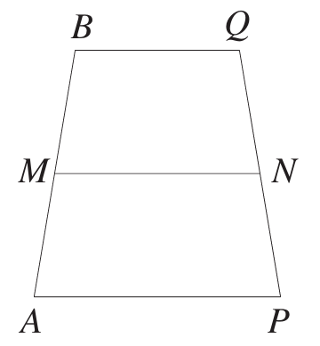
- M and N are the midpoints of AB and PQ.
Let $\overset{̰}{u}= \vec{AM}$, $\overset{̰}{v}= \vec{PN}, \overset{̰}{a}= \vec{AP}, \overset{̰}{b}= \vec{BQ}$ and $\overset{̰}{p}= \vec{MN}$.
  - Explain why $\vec{MB}=\overset{̰}{u}$ and $\vec{NQ} = \overset{̰}{v}$.

$\vec{AM}$ and $\vec{MB}$ have the same length and direction.
Similarly, $\vec{PN}$ and $\vec{NQ}$ have the same length and direction.
  - Find $\overset{̰}{a}$ and $\overset{̰}{b}$ in terms of $\overset{̰}{p}, \overset{̰}{u}$ and$\overset{̰}{v}$.
$$\vec{AN} = \vec{AP} + \vec{PN} = \overset{̰}{a} + \overset{̰}{v} \\ and \vec{AN} = \vec{AM} + \vec{MN} = \overset{̰}{u} + \overset{̰}{p} \\ Hence, \\ \overset{̰}{a} + \overset{̰}{v} = \overset{̰}{u} + \overset{̰}{p} \\ \overset{̰}{a}= \overset{̰}{p}+ \overset{̰}{u}- \overset{̰}{v}, \\ Similarly, \vec{MQ} = \vec{MB} + \vec{BQ} = \overset{̰}{u} + \overset{̰}{b} \\ and \vec{MQ} = \vec{MN} + \vec{NQ} = \overset{̰}{p}+ \overset{̰}{v} \\ Hence, \\ \overset{̰}{u} + \overset{̰}{b}= \overset{̰}{p}+ \overset{̰}{v} \\ \overset{̰}{b}= \overset{̰}{p}- \overset{̰}{u}+ \overset{̰}{v}$$
  - Hence show that $\overset{̰}{a}+ \overset{̰}{b}= 2\overset{̰}{p}$.
$$\overset{̰}{a}+ \overset{̰}{b}= \overset{̰}{p}+ \overset{̰}{u}- \overset{̰}{v}+ \left(\overset{̰}{p}- \overset{̰}{u}+ \overset{̰}{v}\right) \\ = 2\overset{̰}{p}$$

- $\vec{NM} = 4\underset{∼}{b}$ and $\vec{JM} =\underset{∼}{a}.$
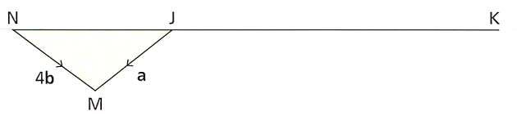
  - Write $\vec{NJ}$ in terms of $\underset{∼}{a}$ and $\underset{∼}{b}.$

$$-\underset{∼}{a} + 4\underset{∼}{b}$$
N, J and K are collinear. $\vec{NK} = 3 × \vec{NJ}$.
  - Write $\vec{NK}$ in terms of $\underset{∼}{a}$ and $\underset{∼}{b}.$

$$-3\underset{∼}{a} + 12\underset{∼}{b}$$
  - Write $\vec{MK}$ in terms of $\underset{∼}{a}$ and $\underset{∼}{b}$.

$$-3\underset{∼}{a}+8\underset{∼}{b}$$

Mastery
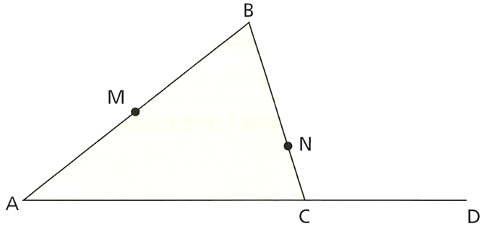
- ABC is a triangle. $\vec{AB} =\underset{∼}{a}$ and $\vec{AC} =2\underset{∼}{b}.$
M is the midpoint of AB.
N is the point on BC such that $BN : NC = 3 : 1$.
D is the point such that $\vec{CD} =\frac{1}{2}\vec{AC}$.
  - Write the vector $\vec{MN}$ in terms of $\underset{∼}{a}$ and $\underset{∼}{b}.$
$$-\frac{1}{4}\underset{∼}{a} +\frac{3}{2}\underset{∼}{b}$$

  - Use vectors to prove that M, N and D lie on the same straight line.
$$\vec{MN} = -\frac{1}{4}\underset{∼}{a} +\frac{3}{2}\underset{∼}{b} = -\frac{1}{4}\left(\underset{∼}{a}-\underset{∼}{6b}\right) \\ \vec{MD} = -\frac{1}{2}\underset{∼}{a} + 3\underset{∼}{b} = -\frac{1}{2}\left(\underset{∼}{a}-\underset{∼}{6b}\right) \\ \vec{MN} and \vec{MD} are parallel and share a common point M. \\ ∴collinear$$

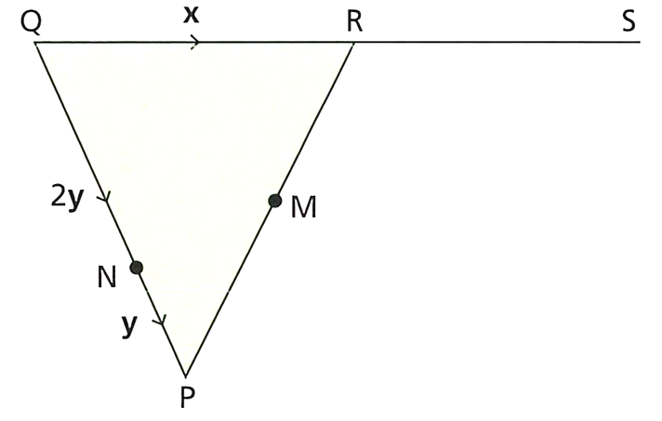
- PQR is a triangle with $\underset{∼}{x},\underset{∼}{y}$ and $2\underset{∼}{y}$ as shown.
N is a point on QP, such that QN = 2NP.
R is the midpoint of QS.
M is the midpoint of PR.
  - Write $\vec{PR}$ in terms of $\underset{∼}{x}$ and $\underset{∼}{y}.$
$$-3\underset{∼}{y}+\underset{∼}{x}$$

  - Write $\vec{NM}$ in terms of $\underset{∼}{x}$ and $\underset{∼}{y}.$
$$-\frac{1}{2}\underset{∼}{y} +\frac{1}{2}\underset{∼}{x}$$

  - Show that NMS is a straight line.
$$\vec{NS} = -2\underset{∼}{y} + 2\underset{∼}{x} = -2\left(\underset{∼}{y}-\underset{∼}{x}\right) \\ \vec{NM} = -\frac{1}{2}\underset{∼}{y} +\frac{1}{2}\underset{∼}{x} = -\frac{1}{2}\left(\underset{∼}{y}-\underset{∼}{x}\right) \\ \vec{NM} and \vec{NS} are parallel and share a common point N. \\ ∴collinear$$

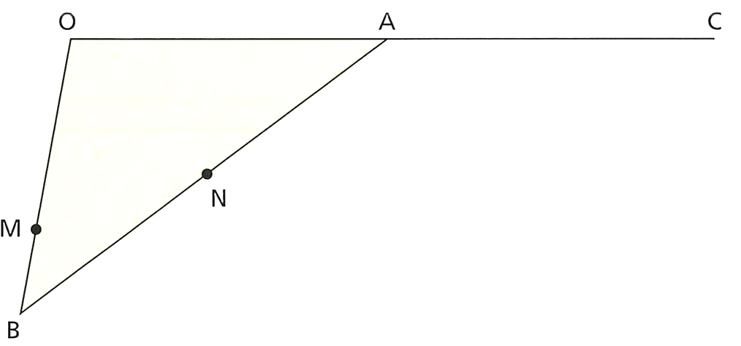
- OAB is a triangle.
A is the midpoint of OC.
N is the midpoint of AB.
M is on OB such that $OM : MB = 2 : 1.$
$\vec{NB} =\underset{∼}{x}$, $\vec{OA} =\underset{∼}{y}.$
Prove that MNC is a straight line.

$$\vec{MN} =\frac{1}{3}\left(2\underset{∼}{x}+\underset{∼}{y}\right) -\underset{∼}{x} \\ = -\frac{1}{3}\left(\underset{∼}{x}-\underset{∼}{y}\right) \\ \vec{MC} = -\frac{4}{3}\underset{∼}{x} +\frac{4}{3}\underset{∼}{y} \\ = -\frac{4}{3}\left(\underset{∼}{x}-\underset{∼}{y}\right) \\ \vec{MN} and \vec{MC} are parallel and share a common point M.$$

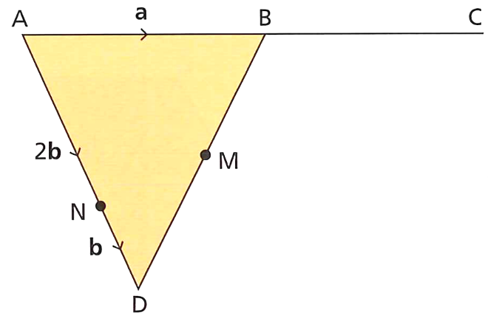
- $ABD$ is a triangle.
$N$ is a point on $AD$ such that $AN : ND = 2 : 1.$
  - Write $\vec{DB}$ in terms of $\underset{∼}{a} and \underset{∼}{b}.$

$$\vec{DB} = -3\underset{∼}{b} +\underset{∼}{a}$$
$B$ is the midpoint of $AC$.
$M$ is the midpoint of $BD$.
  - Show that NMC is a straight line.

$$\vec{NM} =\frac{1}{2}\left(-\underset{∼}{b}+\underset{∼}{a}\right), \vec{NC}=2\left(-\underset{∼}{b}+\underset{∼}{a}\right)$$
Therefore, parallel and share a common point N.

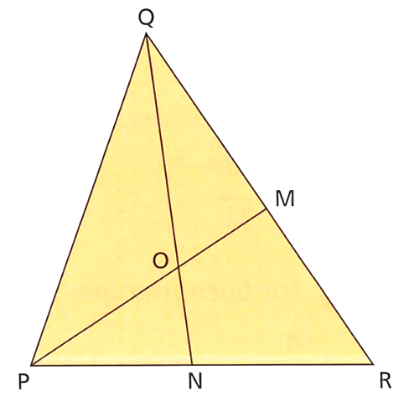
- The triangle $PQR$ is shown. $M$ is the midpoint of $QR$.
$\vec{PR} =\underset{∼}{x}, \vec{PQ} =\underset{∼}{y}.$
$\vec{PO} : \vec{OM} = 3 : 2.$
$\vec{PN}$ can be written in the form $k\underset{∼}{x}.$
Work out the value of $k$.
$$\vec{PR} =\underset{∼}{x}, \vec{PQ} =\underset{∼}{y} \\ \vec{QR} =\underset{∼}{x}-\underset{∼}{y} \\ \vec{QM} =\frac{1}{2}\left(\underset{∼}{x}-\underset{∼}{y}\right)$$

$$\vec{PQ} + \vec{QM} = \vec{PM} \\ \underset{∼}{y}+\frac{1}{2}\left(\underset{∼}{x}-\underset{∼}{y}\right)= \vec{PM} \\ ∴ \vec{PM} =\frac{1}{2}\left(\underset{∼}{x}+\underset{∼}{y}\right)$$

$$\vec{PO} =\frac{3}{5}\left(\underset{∼}{\frac{1}{2}x}+\underset{∼}{y}\right) =\frac{3}{10}\left(\underset{∼}{x}+\underset{∼}{y}\right) \\ \vec{PO} = \vec{PQ} + \vec{QO} \\ \vec{PO} = \vec{PQ} + m × \vec{QN} \\ \frac{3}{10}\left(\underset{∼}{x}+\underset{∼}{y}\right) =\underset{∼}{y}+ m\left(\underset{∼}{kx}-\underset{∼}{y}\right) \\ ∴\frac{3}{10}\underset{∼}{x}+\frac{3}{10}\underset{∼}{y}= mk\underset{∼}{x}+ \left(1-m\right)\underset{∼}{y}$$
Comparing coefficients:
$$mk =\frac{3}{10} \\ 1-m =\frac{3}{10} \\ m =\frac{7}{10} \\ ∴ k =\frac{3}{7}$$

